**Competitive Market Analysis on Edu-Tech Companies for Non-Profit Organization**

**ABSTRACT**

Competitive market analysis is the process of researching and analyzing the competition in a particular industry or market. It involves gathering information about competing businesses, including their products or services, pricing strategies, marketing tactics, and overall market position. The purpose of competitive market analysis is to help businesses understand their competitor’s strengths and weaknesses, identify potential opportunities for differentiation, and develop strategies to gain a competitive advantage. A competitive analysis on Educational Technology (Edu-Tech) companies was conducted in the year 2022-23, that included most of the top performing businesses that provided free or paid courses, mentorship programs, live sessions, interactive classes and targeted study material. The organization selected various companies that has to be analyzed.

A small survey was done among the students to know the necessity of the coaching program. The data was prepared, processed, analyzed, and then presented to the board members. The different software used for the analysis are Sheets, Docs, Drive, Slides from Google, SQL Databases, Python, Tableau. The data analysis showed a similar pattern among the analyzed companies. The survey showed that there is a skill gap issue and industrial training is necessary. Most of the top companies has followed a similar structure and roadmap which led to their success. The analysis also showed how each company has a unique value proposition. The organization gained valuable insights on what decisions to make to compete against the market. The GDCP company has taken this outcome of the analysis and developed new strategies to combat the existing market.



**TABLE OF CONTENT**

|  |  |  |
| --- | --- | --- |
| **Chapters** | **Particular** | **PAGE NO.** |
| **Chapter- I** | **INTRODUCTION OF THE STUDY** | **1** |
|  | 1.2 Industry Profile | **3** |
|  | 1.3 Company Profile | **13** |
| **Chapter- II** | **COMPATITIVE ANALYSIS** | **15** |
|  | 2.1 Methodology | **15** |
|  | 2.2 Gathering Competitive Analysis Data | **15** |
|  | 2.3 Hypothesis | **16** |
|  | 2.4 Competitive Analysis Process | **17** |
|  | 2.5 Competitive Companies | **22** |
|  | 2.6 Competitor Matrix | **24** |
|  | 2.7 Strength and Weakness Analysis | **25** |
|  | 2.8 Market Share Analysis Process | **28** |
|  | 2.9 Product feature analysis | **29** |
|  | 2.10 Benchmarking | **32** |
| **Chapter- III** | **3.RESEARCH METHODOLOGY** | **34** |
|  | 3.1 Research Design | **34** |
|  | 3.2 Methodology | **34** |
|  | 3.3 Statistical techniques | **34** |
|  | 3.4 Pilot Study | **34** |
|  | 3.5 Type of Research | **35** |
|  | 3.6 Tools of Data Collection | **35** |
|  | 3.7 Objectives of study | **37** |
|  | 3.8 Statement of the Problem | **37** |
|  | 3.9 Scope of the study | **38** |
|  | 3.10 Limitations of the analysis | **38** |
| **Chapter- IV** | **DATA ANALYSIS AND INTERPRETATIONS** | **40** |
| **Chapter- V** | **FINDINGS, SUGGESTIONS AND CONCLUSION** | **66** |
|  | Bibliography | **69** |
|  | Questionnaire | **71** |

**List of Tables**

|  |  |  |
| --- | --- | --- |
| **Table** | **Particular** | **Page. No** |
| **4.1** | **Assessing Satisfaction with Current Teaching Methods** | **40** |
| **4.2** | **Preference for Practical Teaching Versus Theoretical Teaching** | **41** |
| **4.3** | **Perceptions of the Value Provided by the Current Education System** | **42** |
| **4.4** | **Perceptions of Ease in Transitioning to the Workforce** | **43** |
| **4.5** | **Perceptions of Job Attainability Based on Current Knowledge and Skills** | **44** |
| **4.6** | **Perceptions of Confidence in Succeeding in Qualification-Related Interviews** | **45** |
| **4.7** | **Perceptions of Training and Skills Gap in Career Preparation** | **46** |
| **4.8** | **Perceptions of Confidence in Meeting Industry Work Standards** | **47** |
| **4.9** | **Adoption of Educational Technology Tools in Learning Activities** | **48** |
| **4.10** | **Perceptions of the Gap between College Education and Industrial Skills in the Workforce** | **49** |
| **4.11** | **Willingness to Acquire Knowledge and Skills in Alignment with Personal Interests** | **50** |
| **4.12** | **Preference for Workshops and Practical Sessions** | **51** |
| **4.13** | **Willingness to Share Knowledge and Skills with Others** | **52** |
| **4.14** | **Perception towards Implementing an Industrial Training Program in Colleges for Career Development** | **53** |
| **4.15** | **Exploring Interest in Joining a Community to Address the Skill Gap Issue** | **54** |
| **4.16** | **Impact of Edu-Tech Platforms on Motivation and Engagement in the Learning Process** | **55** |
| **4.17** | **Satisfaction with Quality, Comprehensiveness, and Pricing of Edu-Tech Course Content** | **56** |
| **4.18** | **Analysis of User-Friendliness and Ease of Navigation of Edu-Tech Platforms' Interface** | **57** |
| **4.19** | **Effectiveness of Personalized Learning Recommendations and Progress Tracking in Achieving Learning Goals** | **58** |
| **4.20** | **Perceived Impact of Educational Technology on Learning Experience** | **59** |
| **4.21** | **Effect of Educational Technology Tools on Academic Performance and Understanding** | **60** |
| **4.22** | **Perceived Value for Money of Edu-Tech Platform's Subscription or Pricing Plans** | **61** |
| **4.23** | **Correlation Analysis: Job Attainability and Training/Skills Gap Perceptions** | **62** |
| **4.24** | **Chi-square Analysis on Perceptions of Edu-Tech Platform Impact and Academic Performance** | **64** |

**List of Charts**

|  |  |  |
| --- | --- | --- |
| **Charts** | **Particular** | **Page. No** |
| **4.1** | **Assessing Satisfaction with Current Teaching Methods** | **40** |
| **4.2** | **Preference for Practical Teaching Versus Theoretical Teaching** | **41** |
| **4.3** | **Perceptions of the Value Provided by the Current Education System** | **42** |
| **4.4** | **Perceptions of Ease in Transitioning to the Workforce** | **43** |
| **4.5** | **Perceptions of Job Attainability Based on Current Knowledge and Skills** | **44** |
| **4.6** | **Perceptions of Confidence in Succeeding in Qualification-Related Interviews** | **45** |
| **4.7** | **Perceptions of Training and Skills Gap in Career Preparation** | **46** |
| **4.8** | **Perceptions of Confidence in Meeting Industry Work Standards** | **47** |
| **4.9** | **Adoption of Educational Technology Tools in Learning Activities** | **48** |
| **4.10** | **Perceptions of the Gap between College Education and Industrial Skills in the Workforce** | **49** |
| **4.11** | **Willingness to Acquire Knowledge and Skills in Alignment with Personal Interests** | **50** |
| **4.12** | **Preference for Workshops and Practical Sessions** | **51** |
| **4.13** | **Willingness to Share Knowledge and Skills with Others** | **52** |
| **4.14** | **Perception towards Implementing an Industrial Training Program in Colleges for Career Development** | **53** |
| **4.15** | **Exploring Interest in Joining a Community to Address the Skill Gap Issue** | **54** |
| **4.16** | **Impact of Edu-Tech Platforms on Motivation and Engagement in the Learning Process** | **55** |
| **4.17** | **Satisfaction with Quality, Comprehensiveness, and Pricing of Edu-Tech Course Content** | **56** |
| **4.18** | **Analysis of User-Friendliness and Ease of Navigation of Edu-Tech Platforms' Interface** | **57** |
| **4.19** | **Effectiveness of Personalized Learning Recommendations and Progress Tracking in Achieving Learning Goals** | **58** |
| **4.20** | **Perceived Impact of Educational Technology on Learning Experience** | **59** |
| **4.21** | **Effect of Educational Technology Tools on Academic Performance and Understanding** | **60** |
| **4.22** | **Perceived Value for Money of Edu-Tech Platform's Subscription or Pricing Plans** | **61** |

**­**

# Chapter-I

**INTRODUCTION**

In recent years, the educational technology (Edu-Tech) industry has witnessed significant growth and transformation, revolutionizing the way education is delivered and accessed. As a non-profit organization operating in the education sector, it is essential to understand the competitive landscape and market dynamics of Edu-Tech companies. A competitive market analysis provides valuable insights into the strengths, weaknesses, opportunities, and threats posed by these companies, enabling the non-profit organization to make informed strategic decisions and enhance its educational offerings.

The purpose of this competitive market analysis is to examine and evaluate the leading Edu-Tech companies in the market and assess their impact on the education sector. By analyzing the key players in the industry, their products and services, target customer segments, pricing models, and technological advancements, the non-profit organization can gain a comprehensive understanding of the competitive landscape and identify opportunities for collaboration, differentiation, and innovation.

This analysis will delve into the strategies employed by Edu-Tech companies, such as BYJU'S, Unacademy, Vedantu, Udemy, Upgrad, Toppr to gain market share and deliver educational solutions. By assessing their strengths and weaknesses, the non-profit organization can identify potential areas for partnerships or leverage their competitive advantages to address unmet educational needs within its target audience.

Ultimately, the competitive market analysis will empower the non-profit organization to make strategic decisions that align with its mission, optimize resource allocation, and enhance its educational impact. By staying informed about the competitive landscape and understanding the trends and innovations within the Edu-Tech industry, the non-profit organization can effectively adapt to the evolving educational landscape and contribute to the advancement of accessible and quality education for all.

This chapter provides an overview of the research which outlines the study based on the background of the analysis, problem statement, objectives of the analysis, research questions, hypotheses, significance, layout of the chapter and conclusion of the study. The purpose of this study is to examine the relationship among the factors that contribute to the degree of change of competitors market which is vital to the business outcomes.

The most commonly studied outcomes of market analysis include Identification of target customers, Evaluation of competitors, Assessments of market trends, Determination of market size and potential, Identification of barriers to entry, Development of pricing strategies. The GDCP organization needed to know about who are their competitors, who are the target audience, and how to capture the market. For this purpose, the research and analysis has been done so that they may take the right decision.

# 1.2 INDUSTRY PROFILE

The educational technology industry in India has experienced significant growth in recent years due to the increasing demand for online education and the availability of advanced Edu Technology. In this report, we will provide an overview of the educational technology industry in India, including its current status, growth potential, challenges, and future prospects.

**Overview of the Educational Technology Industry in India**

India is one of the largest education markets in the world, with more than 1.5 million schools and over 260 million students enrolled. The country's education system is undergoing a transformation, with a growing emphasis on digital learning and e-education. This has led to the rapid growth of the educational technology industry in India, which is expected to reach USD 10 billion by 2025.

However, the quality of education in the country has been a concern, with issues such as inadequate infrastructure, limited access to resources, and low teacher-student ratios impacting the learning outcomes of students.

To address these challenges, the educational technology industry in India has been developing and delivering innovative solutions that leverage technology to provide quality education to students across the country. Some of the key areas where educational technology is making an impact include:

1. K-12 Education: The K-12 segment is the largest market for educational technology in India, accounting for more than 60% of the market share. Educational technology companies are developing and delivering online courses, digital textbooks, and other innovative tools and platforms to improve the learning outcomes of students in this segment.
2. Higher Education: The higher education segment is also witnessing significant growth, with increasing demand for online courses and digital learning platforms. Educational technology companies are partnering with universities and other institutions to deliver online courses and degrees, providing students with access to quality education from anywhere in the country.
3. Skills Training: The skills training segment is another area where educational technology is making an impact. With the increasing demand for job-specific skills and vocational training, educational technology companies are developing and delivering online courses and training programs that enable students to acquire the skills they need to succeed in the workforce.

**Current Status of the Educational Technology Industry in India**

The educational technology industry in India is currently at a nascent stage but is growing rapidly. The market is highly fragmented, with a large number of small and medium-sized companies competing for market share. However, there are a few key players that dominate the market, including BYJU'S, Simplilearn, UpGrad, and Vedantu.

The COVID-19 pandemic has accelerated the growth of the educational technology industry in India, as schools and colleges were forced to shut down and shift to online learning. This led to a surge in demand for online courses, and many educational technology companies in India experienced a significant increase in user engagement and revenue.

**Growth Potential of the Educational Technology Industry in India**

The educational technology industry in India has significant growth potential, driven by the increasing demand for online education and the availability of advanced Technology. The market is expected to grow at a CAGR of 17.4% from 2020 to 2025, reaching USD 10 billion by 2025.

The K-12 segment is expected to remain the largest segment, accounting for more than 60% of the market share. However, higher education and skills training are also expected to grow rapidly, driven by the increasing demand for online courses and job-specific training.

**Challenges Facing the Educational Technology Industry in India**

Despite its growth potential, the educational technology industry in India faces several challenges, including:

**Infrastructure**: A lack of infrastructure, including reliable internet connectivity and digital devices, is a significant challenge for the growth of the educational technology industry in India.

1. **Quality of Content**: The quality of content available on educational technology platforms is a concern for many users, as there is a wide range of content quality available.
2. **Regulatory Framework**: The regulatory framework for the educational technology industry in India is still evolving, which can create uncertainty for businesses operating in this space.
3. **Digital Divide**: The digital divide in India, where access to technology and education is limited in certain areas, is a significant challenge for the growth of the educational technology industry in India.

**Future Prospects of the Educational Technology Industry in India**

Despite these challenges, the educational technology industry in India has a promising future. The increasing adoption of digital learning and the availability of advanced Technology are expected to drive the growth of the industry in the coming years.

In conclusion, the educational technology industry in India has significant growth potential, driven by the increasing demand for online education and the availability of advanced Technology. However, the industry also faces several challenges that must be addressed for it to reach its full potential. With the right policies and infrastructure in place, the educational technology industry in India can play a significant role in transforming the country's education system.

# Importance of Industry Analysis:

Industry analysis is of significant importance for businesses and organizations for several reasons:

1. Understanding the Market: Industry analysis helps businesses gain a deep understanding of the market in which they operate. It provides insights into market size, growth rate, customer segments, and market trends. This knowledge allows organizations to identify market opportunities, target the right customers, and tailor their products or services to meet customer needs effectively.
2. Assessing Competitive Landscape: Industry analysis enables businesses to evaluate their competitors and understand their strengths, weaknesses, strategies, and market positioning. By studying the competitive landscape, organizations can identify their competitive advantage, differentiate themselves from rivals, and develop effective strategies to outperform competitors.
3. Identifying Opportunities and Threats: Through industry analysis, businesses can identify both opportunities and threats that exist in the market. It helps in identifying emerging trends, technological advancements, and market gaps that can be exploited for growth. Similarly, it helps in recognizing potential threats such as new entrants, substitute products or services, and changing customer preferences that can pose risks to the organization's market position.
4. Making Informed Business Decisions: Industry analysis provides critical insights that guide strategic decision-making. It assists in determining product development and innovation strategies, pricing strategies, distribution channels, and marketing approaches. By basing decisions on industry analysis, organizations can make informed choices that align with market conditions and maximize their chances of success.
5. Anticipating and Adapting to Market Changes: Industry analysis helps businesses anticipate and adapt to market changes. It enables organizations to stay updated on industry trends, technological advancements, and regulatory changes that may impact their operations. By proactively monitoring the industry, businesses can make timely adjustments to their strategies, products, or services to remain competitive and relevant in a dynamic market.
6. Risk Mitigation: Industry analysis allows organizations to identify potential risks and challenges associated with the industry. By understanding market dynamics and potential disruptions, businesses can develop contingency plans and risk mitigation strategies to safeguard their operations and navigate uncertain situations.

## Profile of Education Technology Industry in India:

The education technology (Edu-Tech) industry in India has emerged as a dynamic and rapidly expanding sector. With a large population, increasing digital adoption, and a growing demand for quality education, the Indian Edu-Tech market has witnessed significant growth in recent years. Key players in the industry offer a range of solutions, including online learning platforms, test preparation services, skill development courses, and personalized learning tools. The industry has been fueled by advancements in technology such as artificial intelligence, machine learning, and data analytics, which have enabled personalized and interactive learning experiences. The COVID-19 pandemic further accelerated the adoption of online learning, driving the industry's growth and transforming the way education is delivered in the country.

The Indian government has also recognized the importance of Edu-Tech and has introduced initiatives and policies to promote digital education. The National Education Policy 2020 and programs like Digital India and SWAYAM have created an enabling environment for innovation and collaboration in the Edu-Tech sector. However, challenges such as unequal access to technology, connectivity issues in rural areas, and ensuring quality and affordability of Edu-Tech solutions remain. Nonetheless, the Edu-Tech industry in India continues to offer immense opportunities for investors, entrepreneurs, and educational institutions to harness technology and provide accessible, personalized, and quality education to learners across the country.

## Segments of Education Technology Industry in India:

The education technology (Edu-Tech) industry in India encompasses various segments that cater to different educational needs and target audiences. Here are some key segments within the Indian Edu-Tech industry:

1. K-12 Education: This segment focuses on providing digital learning solutions for students in kindergarten to grade 12. It includes platforms that offer interactive and engaging content aligned with school curriculum, online tutoring services, homework help, and educational games.
2. Test Preparation: Test preparation is a significant segment within the Indian Edu-Tech industry, catering to students preparing for competitive exams such as engineering, medical, and management entrance exams. Test preparation platforms provide online courses, practice tests, performance analytics, and personalized study plans to help students excel in their exams.
3. Higher Education and Skill Development: This segment targets college students and working professionals seeking higher education opportunities and skill development. Edu-Tech platforms offer online degree programs, certificate courses, industry-specific training, and upskilling programs to enhance career prospects and acquire new skills.
4. Language Learning: Language learning has gained prominence in the Edu-Tech space, with platforms offering online language courses and interactive tools to learn languages effectively. These platforms focus on teaching multiple languages, including English, regional languages, and foreign languages.
5. Professional Development and Corporate Training: This segment focuses on providing online courses and training programs for professionals to enhance their skills, acquire industry-specific knowledge, and advance their careers. It includes platforms that offer courses in areas such as leadership development, project management, digital marketing, and data analytics.
6. Vocational Training: Vocational training is an emerging segment within the Indian Edu-Tech industry, catering to individuals seeking specific job-oriented skills. Edu-Tech platforms in this segment offer courses in areas such as coding, graphic design, culinary arts, fashion designing, and entrepreneurship to equip learners with practical skills for employment.
7. Early Childhood Education: This segment focuses on providing early childhood learning experiences through interactive digital platforms. It includes Edu-Tech solutions that offer educational games, interactive storybooks, and activities to enhance early literacy, numeracy, and cognitive skills in young children.

## Market Size of Education Technology Industry in India:

The education technology (Edu-Tech) industry in India has experienced remarkable growth in recent years, driven by various factors such as increasing internet penetration, smartphone usage, and digital literacy. The market size of the Indian Edu-Tech industry has expanded significantly, reflecting the rising demand for digital learning solutions and the need for accessible and quality education.

According to reports and industry estimates, the Indian Edu-Tech market was valued at approximately $2.8 billion in 2020. It is projected to reach a market size of around $10.4 billion by 2025, growing at a compound annual growth rate (CAGR) of over 28%. This growth trajectory can be attributed to several key factors:

1. Increasing Digital Penetration: India has witnessed a rapid increase in internet penetration, with a significant number of people gaining access to smartphones and affordable data plans. This has enabled widespread adoption of online education platforms and digital learning resources, contributing to the expansion of the Edu-Tech market.
2. Changing Learning Landscape: The traditional education system has been supplemented and transformed by digital technologies, creating new opportunities for learners and educators. The demand for flexible learning options, personalized experiences, and access to quality educational content has propelled the growth of the Edu-Tech industry.
3. COVID-19 Pandemic: The outbreak of the COVID-19 pandemic in 2020 further accelerated the growth of the Edu-Tech industry in India. With educational institutions temporarily closed and physical classroom learning disrupted, online learning became the primary mode of education. This led to a significant surge in demand for online courses, virtual classrooms, and remote learning platforms.
4. Government Support and Initiatives: The Indian government has recognized the importance of Edu-Tech in transforming the education landscape and has introduced various initiatives to promote digital education. Programs like Digital India, SWAYAM (Study Webs of Active Learning for Young Aspiring Minds), and National Digital Library have provided a framework for Edu-Tech innovation and accessibility.

The market size of the Indian Edu-Tech industry is expected to witness continuous growth in the coming years as more learners and educational institutions embrace online learning and digital resources. The availability of affordable smartphones, internet connectivity, and the push towards digital literacy are likely to fuel further market expansion. Additionally, the rising demand for upskilling and reskilling in a rapidly evolving job market is expected to contribute to the growth of the professional development and skill enhancement segment within the Edu-Tech industry.

It is important to note that the Edu-Tech market size figures mentioned above are estimates and may vary depending on different sources and methodologies used for calculation. The Edu-Tech landscape in India is evolving rapidly, and market dynamics are subject to change based on various factors, including technological advancements, regulatory frameworks, and user preferences.

## Factors Affecting Healthcare Industry in India:

The education technology (Edu-Tech) industry in India is influenced by various factors that shape its growth, adoption, and overall landscape. Understanding these factors is crucial for stakeholders in the industry to navigate challenges, identify opportunities, and drive innovation. Here are some key factors that affect the education technology industry in India:

1. Digital Infrastructure and Connectivity: The availability and quality of digital infrastructure, including internet connectivity and access to devices, play a significant role in the adoption of Edu-Tech solutions. Unequal access to reliable internet connectivity, especially in rural and remote areas, can hinder the widespread use of online learning platforms and limit their reach.
2. Government Policies and Regulations: Government policies and regulations have a significant impact on the Edu-Tech industry. Supportive policies, funding initiatives, and regulatory frameworks that encourage innovation, collaboration, and accessibility can boost the growth of the sector. Additionally, policies related to data privacy, content standards, and certification may influence the operations and offerings of Edu-Tech companies.
3. Digital Literacy and Awareness: The level of digital literacy and awareness among the target audience, including students, parents, and educators, can influence the adoption and acceptance of Edu-Tech solutions. Efforts to improve digital literacy and create awareness about the benefits and usage of technology in education are crucial to drive the widespread adoption of Edu-Tech platforms.
4. Affordability and Accessibility: Affordability of Edu-Tech solutions and accessibility for diverse socio-economic groups are significant factors that affect their adoption. Making digital learning resources and devices affordable, as well as addressing language barriers and catering to regional and cultural diversity, can ensure inclusivity and equitable access to education technology.
5. Pedagogical Effectiveness: The effectiveness of Edu-Tech solutions in supporting learning outcomes is a critical factor that influences their adoption. Edu-Tech platforms that offer engaging and interactive content, personalized learning experiences, adaptive assessments, and effective feedback mechanisms are more likely to be embraced by students, educators, and parents.
6. Industry Collaboration and Partnerships: Collaboration between Edu-Tech companies, educational institutions, and industry stakeholders can drive innovation, enhance content quality, and provide relevant skill development opportunities. Partnerships between technology providers and educational institutions can foster research and development, enable knowledge sharing, and create scalable solutions.
7. Changing Learning Needs and Market Demands: The evolving nature of the job market, emerging skills requirements, and changing learning needs influence the demand for Edu-Tech solutions. Edu-Tech companies need to stay abreast of market trends, align their offerings with industry demands, and continuously adapt to changing learner requirements.
8. Impact of Disruptive Technologies: Disruptive technologies such as artificial intelligence, machine learning, augmented reality, and virtual reality are reshaping the Edu-Tech landscape. Embracing these technologies and leveraging their potential to create immersive learning experiences, personalized content delivery, and data-driven insights can drive innovation and transform education.
9. User Experience and Feedback: User experience and feedback play a vital role in the success of Edu-Tech platforms. Designing user-friendly interfaces, incorporating feedback mechanisms, and continuously iterating based on user input are critical to enhancing user satisfaction and engagement.
10. Socio-cultural Factors: Socio-cultural factors, including societal attitudes towards online learning, traditional education norms, and cultural preferences, can impact the adoption and acceptance of Edu-Tech solutions. Understanding and addressing these factors can help Edu-Tech companies tailor their offerings to local contexts and ensure cultural relevance.

# 1.3 COMPANY PROFILE

# GLOBAL DEVELOPMENT COMMUNITY PROGRAM:

The Global Development Community Program (GDCP) organization is dedicated to solve the problems faced by the industry and the work force. The common problem is there is lack of skill or industrial training that is needed to transition to the work force.

The Global Development Community Program (GDCP) is a classic learning and working model designed specifically for those pursuing any Bachelor or engineering, or those with skills and passion for software development, to work on projects with mentors from the same business sector. This initiative is ideally suited for students and young professionals who want to get into software-based product development.

S**ome of the problems faced in the industry or by the work force include:**

1. Education/Knowledge (Gap) imparted in college to the practical knowledge needed in the industry
2. Lack of skill and Employee Behavior Check
3. Lack of Skill Development and technology Upgradation Opportunity
4. Lack of R&D facilitation.
5. Waiting Period of a fresher employee inside the industry to get the actual practical project for growth and development

We are creating a Non-Profit organization; under that organization we are developing required verticals of different volunteers’ community like

* Social Entrepreneurs Community
* Human Resource Community
* Content Writer Community
* Social Media Marketing Community
* Videography Community
* Marketing Community
* Software Development Community
* College Ambassador Community
* General Volunteers Community
* Public relation Manager Community
* Corporate & Government Delegates Relationship Manager Community

**Our Mission**

To solve this unidentified critical problem of unskilled human resources, knowledge Gap between education institutes to the industry requirement and lack of Timely Technology upgradation platform for existing students and working professionals.

**Our Mission**

To create a fully automated structure within the organizations run by volunteers who identify, process, solve various problems of the society in a global scale.

# Chapter-II

**Competitive Analysis**

**2.1 Methodology**:

The methodology for conducting a competitive analysis of Ed Tech companies typically involves several steps. Firstly, it is important to identify the key players in the industry and gather data on their market share, revenue, and growth trajectory. This can be done through a combination of secondary research and primary research, such as surveys and interviews with industry experts. Once this information has been gathered, it is important to analyze the strengths and weaknesses of each player, as well as their strategies for differentiation and cost leadership.

This can involve a detailed SWOT analysis or Porter's Five Forces analysis. Additionally, it may be useful to analyze broader trends in the Ed Tech industry, such as the impact of emerging technologies, changing consumer preferences, and regulatory developments. Finally, it is important to draw insights from the analysis and use these to inform strategic decision-making for Ed Tech companies. This may involve identifying opportunities for growth or areas where the company needs to improve its competitive position. Overall, a rigorous and data-driven methodology is essential for conducting a meaningful competitive analysis of Ed Tech companies.

# 2.2 Gathering Competitive Analysis Data:

Gathering competitive analysis data for Ed Tech companies can involve several methods.

**Primary research**: This involves collecting data directly from the source, such as through surveys, interviews, or focus groups. Primary research can provide valuable insights into customer preferences, market trends, and competitive positioning.

**Secondary research:** This involves collecting data from existing sources such as industry reports, academic papers, and government publications. Secondary research can provide a broader context for the analysis and help identify trends and patterns in the market.

**Competitive intelligence:** This involves monitoring and analyzing the activities of competitors through sources such as public filings, press releases, and social media. Competitive intelligence can provide insights into the strengths and weaknesses of competitors and their strategies for growth.

**Market analysis tools**: There are several market analysis tools available that can provide insights into the Ed Tech market, such as market research reports, SWOT analysis, and Porter's Five Forces analysis. These tools can help identify the key players in the market, their market share, and their strategic priorities.

**Web analytics:** This involves analyzing data from website traffic and user behavior to understand customer preferences and market trends. Web analytics can provide insights into the effectiveness of different marketing and sales strategies and help identify opportunities for growth.

The choice of data gathering methods will depend on the specific research objectives, the available resources, and the nature of the Ed Tech market. A combination of these methods can provide a comprehensive understanding of the competitive dynamics of the market and help identify opportunities for growth and differentiation.

# 2.3 Hypothesis:

Hypotheses are the essential assumptions which the researcher formulates about the possible causes, findings and ultimate output of the issue under research. Under hypotheses mere assumptions or suppositions are made which are to be proved or disproved. For researchers it is a formal question that he intends to resolve. Hypotheses consist either of a suggested explanation for a phenomenon or of a reasoned proposal suggesting a possible correlation between multiple phenomenon. The assumptions be true or false are to be proved through the completion of project.

# The hypotheses for this project are as follows:

Hypothesis 1: Ed Tech companies that prioritize personalized learning and adaptive technology will be more successful in the market than those that do not.

Hypothesis 2: The increasing demand for affordable and accessible education solutions will lead to more competition in the Ed Tech market.

Hypothesis 3: The market share of established Ed Tech companies will be threatened by the entry of new and innovative players in the market.

Hypothesis 4: Ed Tech companies that offer a wide range of products and services will have a competitive advantage over those that specialize in one area.

Hypothesis 5: The success of Ed Tech companies will be closely tied to their ability to leverage emerging technologies such as artificial intelligence and machine learning.

Hypothesis 6: Ed Tech companies that prioritize partnerships and collaborations with educational institutions and governments will be more successful in expanding their reach and impact.

# 2.4 Competitive Analysis Process:

Competitive analysis is the process of identifying competitors in our industry and researching their different marketing strategies.

**1. Identify our competitors**

To create a list of potential competitors, consider where the customers would turn if they didn’t buy from our company. An easy way to start is to search the product name or category on Google or another search engine and explore the results. We can also survey or interview existing customers to ask them what alternatives they considered before deciding on our product or service.

* Direct competitors

Direct competitors sell a similar product or service to a similar target audience. These are likely the companies that first come to mind when we think of our competition.

* Indirect competitors

Indirect competitors sell a different product or service in the same category but target an audience like ours.

When conducting a competitor analysis, we should focus most of our attention on direct and indirect competitors. Still, it’s worth briefly taking stock of potential replacement competitors that could threaten our business prospects.

**2. Create a competitor matrix**

A competitor matrix, also known as a competitor grid, is a table or spreadsheet we can use to compile our research. This will make it easier to compare our findings between competitors and spot larger trends.

Start by devoting one row or column to each competitor that we’ve identified. On the other axis, list data points or categories of information we’d like to find out about each competitor.

**3. Gather background information**

Once we have a list of competitors to research, start learning about their businesses. Look for the most basic information first, and then build our way up from there. Start by looking at company websites, social media pages, and any news articles that have been published about them. Here’s some basic information that we may want to look for.

* **Company history**

This includes information such as founding date, funding sources, and any mergers or acquisitions they have been involved with. we can often find this information by reading the “About” section of their website or browsing past press releases from the company. Studying how our competitors got to where they are today will give us a more complete understanding of their businesses.

* **Location**

This will vary greatly based on our industry. If we’re in the e-commerce business, we could be competing against companies that sell their products worldwide. For traditional businesses, our competition is likely highly localized. Either way, it’s always smart to know where our competition is based and where they sell.

* **Company size**

How many people do our competitors employ? LinkedIn and Glassdoor are helpful resources for this kind of data. we’ll also want to look into how many customers our competitors have and how much revenue they generate. This information will likely be easily accessible online for larger companies. For smaller and privately held companies, we might have to make do with rough estimates. Knowing how large our competitors are will help we better contextualize the rest of the data we collect.

**4. Profile our competition’s target customers**

A company is nothing without its customers. Getting an idea of who our competitors sell to will tell we a lot about their businesses. To pinpoint the target customer for any business:

1. Read their mission statement.
2. Look at what kind of messaging they use.
3. Track who they interact with on social media.
4. See if they feature any existing customers in their content.

Use this information to construct a profile of who our competitors are trying to reach with their products or services. These customer profiles will probably resemble our own target customers—these are our competitors, after all—so make note of even small differences.

**5. Focus on the 4 P’s**

Now that we’ve identified the target customer for each competitor, it’s time to look into how they go about reaching that segment of the market. This will require a deep dive into their marketing strategies.

The marketing mix, also known as the 4 P’s—product, price, promotion, and place—covers the must-have elements when bringing a product to market. As part of our research, ask ourself the following questions for each competitor we’ve selected.

* **Product**

1. What are they selling?
2. What features are included in their product or service?
3. What is most appealing to customers about the product or service? What are some weak points of the product or service? (Pro tip: Check out customer reviews.)

* **Price**

1. What kind of pricing model do they use? Is it a one-time purchase or a subscription?
2. How much do they charge for their product or service? Do they offer sales or discounts?
3. How does their pricing reflect the quality, or perceived quality, of their product or service?

* **Promotion**

1. How do they get the word out about their product or service? What advertising channels (social media, email marketing, print advertisements, etc.) do they use?
2. What elements of their product or service do they emphasize? What’s their unique selling proposition?
3. What’s their company story? How do they talk about their brand?

* **Place**

1. Where do they sell their product? Do they sell online or in brick-and-mortar locations?
2. Do they sell to customers directly, or do they partner with retailers or third-party marketplaces?

**6. Analyze strengths and weaknesses—ours and our competitors’**

Using the information we’ve collected, consider the strengths and weaknesses of each of our selected competitors. Ask ourself why consumers choose a particular company’s product or service over the other available options. Record our conclusions in our spreadsheet.

Last, consider our own company’s strengths and weaknesses. How does our business compare to the competitors we’ve researched? Knowing what sets our business apart from the competition—and where it falls short of expectations—can help we better serve our target customers.

# 2.5 Competitive Companies:

There are several Edu Tech companies operating in India, each offering a range of products and services. Here are some of the top Edu Tech companies in India:

**BYJU's:** BYJU's is one of the largest Edu Tech companies in India, offering online learning solutions for K-12 students. The company's learning app is used by over 80 million students across India.

**Unacademy:** Unacademy offers a range of online courses and classes for students preparing for competitive exams, such as JEE, NEET, and UPSC. The company also offers courses on a range of other subjects, including coding, photography, and public speaking.

**Vedantu**: Vedantu offers live online tutoring for K-12 students in India. The platform connects students with qualified teachers and offers personalized learning solutions to help students improve their academic performance.

**Simplilearn**: Simplilearn offers online courses and certification programs in a range of subjects, including IT, digital marketing, and project management. The company also offers corporate training solutions for businesses.

**Toppr**: Toppr offers a range of learning solutions for K-12 students, including online classes, practice tests, and study materials. The company's platform uses artificial intelligence and machine learning to personalize learning solutions for each student.

**upGrad**: upGrad offers online courses and certification programs in a range of subjects, including data science, management, and software engineering. The company also offers executive education solutions for working professionals.

**Testbook**: Testbook offers online test preparation solutions for a range of competitive exams, including banking, SSC, and railways. The company's platform offers mock tests, study materials, and personalized learning solutions.

# Background Information:

# Here is some background information on the top Edu Tech companies in India:

# BYJU's: BYJU's is one of the largest Ed Tech companies in India. It was founded in 2011 by Byju Raveendran and provides online learning solutions for K-12 students. BYJU's offers video lessons, interactive quizzes, and other study materials in various subjects. It has over 100 million registered users and has been valued at over $16 billion.

# Unacademy: Unacademy is a platform for online courses and classes for competitive exam preparation. It was founded in 2015 by Gaurav Munjal, Roman Saini, and Hemesh Singh. Unacademy offers live classes, recorded video lessons, and practice tests for various competitive exams such as UPSC, SSC, and banking exams. It has over 50,000 registered educators and more than 40 million learners.

# Vedantu: Vedantu is an online tutoring platform for K-12 students. It was founded in 2014 by Vamsi Krishna, Anand Prakash, and Pulkit Jain. Vedantu offers live one-on-one tutoring sessions, group classes, and study materials in various subjects. It has over 1 million registered students and more than 30,000 teachers.

# Simplilearn: Simplilearn is an online learning platform that offers certification courses in various subjects such as data science, cybersecurity, and project management. It was founded in 2010 by Krishna Kumar. Simplilearn provides self-paced video courses, live online classes, and hands-on projects. It has over 2 million registered learners and has partnerships with over 1,500 companies.

# Toppr: Toppr is a learning app for K-12 students that offers online classes, practice tests, and study materials. It was founded in 2013 by Zishaan Hayath and Hemanth Goteti. Toppr provides personalized learning plans and adaptive practice tests in various subjects. It has over 12 million registered students.

# upGrad: upGrad is an online learning platform that offers certification courses in various subjects such as management, data science, and software engineering. It was founded in 2015 by Ronnie Screwvala, Mayank Kumar, Phalgun Kompalli, and Ravijot Chugh. upGrad provides self-paced video courses, live online classes, and personalized mentorship. It has over 1 million registered learners.

# Testbook: Testbook is an online test preparation platform for competitive exams such as SSC, banking, and railways. It was founded in 2014 by Ashutosh Kumar and Narendra Agrawal. Testbook provides mock tests, video lessons, and study materials in various subjects. It has over 20 million registered users and has been funded by investors such as Iron Pillar and Matrix Partners.

# 2.6 Competitor Matrix:

# Here is a competitor matrix of the top Edu Tech companies in India, comparing their products, services, and target markets:

|  |  |  |
| --- | --- | --- |
| **Company** | **Products/Services** | **Target Market** |
| BYJU's | Online learning solutions for K-12 students | K-12 students |
| Unacademy | Online courses and classes for competitive exam preparation | Students preparing for exams |
| Vedantu | Live online tutoring for K-12 students | K-12 students |
| Simplilearn | Online courses and certification programs in various subjects | Working professionals and students |
| Toppr | Learning solutions for K-12 students, including online classes, practice tests, and study materials | K-12 students |
| upGrad | Online courses and certification programs in various subjects | Working professionals |
| Testbook | Online test preparation solutions for competitive exams | Students preparing for exams |

This competitor matrix provides a quick comparison of the various Edu Tech companies operating in India. It highlights the products and services offered by each company, as well as their target markets.

This information can be useful for investors, educators, and students who are looking to understand the Edu Tech landscape in India and make informed decisions about which companies to invest in or partner with.

# 2.7 Strength and Weakness Analysis:

1. **BYJU'S:**

Strengths:

* Wide range of courses for K-12 students
* Offers test prep courses for various entrance exams
* Innovative teaching techniques such as visual learning and adaptive learning
* Strong brand reputation

Weaknesses:

* High pricing may not be affordable for all students
* Focus mainly on K-12 students, limiting potential customer base
* Limited presence in the global market

1. **Unacademy:**

Strengths:

* Wide range of courses for various competitive exams
* Affordable pricing options for courses
* Strong emphasis on student engagement and interactive learning
* Offers live classes and interactive sessions

Weaknesses:

* Quality of courses may not be consistent across all educators
* Limited presence in the global market
* Limited course offerings for non-competitive exam fields

1. **Vedantu:**

Strengths:

* Offers live online classes for K-12 students
* Highly qualified educators with personalized attention to students
* Affordable pricing options for courses
* Offers test prep courses for various entrance exams

Weaknesses:

* Limited course offerings for non-K-12 students
* Limited presence in the global market
* High competition from other online tutoring platforms

1. **Simplilearn:**

Strengths:

* Wide range of courses in various fields
* Offers online courses for working professionals and students
* Provides certification for completion of courses
* Strong partnerships with industry leaders

Weaknesses:

* Limited focus on K-12 education
* High pricing may not be affordable for all students and professionals
* Quality of courses may not be consistent across all instructors

1. **Upgrad:**

Strengths:

* Wide range of courses in various fields
* Offers online courses for working professionals to upskill or reskill
* Strong partnerships with industry leaders
* Provides certification for completion of courses

Weaknesses:

* Limited focus on K-12 education
* High pricing may not be affordable for all students and professionals
* Limited presence in the global market

1. **Toppr:**

Strengths:

* Offers a wide range of courses for K-12 students
* Innovative teaching techniques such as adaptive learning
* Offers test prep courses for various entrance exams
* Provides personalized attention to students

Weaknesses:

* Limited focus on non-K-12 education
* High pricing may not be affordable for all students
* Limited presence in the global market

1. **WhiteHat Jr:**

Strengths:

* Specializes in teaching coding to children
* Innovative teaching techniques such as game-based learning
* Highly qualified educators with personalized attention to students
* Strong emphasis on skill-building and critical thinking

Weaknesses:

* Limited focus on non-coding education
* High pricing may not be affordable for all students
* Limited course offerings for older age groups

1. **Embibe:**

Strengths:

* Personalized test preparation courses for various competitive exams
* Innovative AI-based tools for self-assessment
* Strong partnerships with industry leaders
* Provides personalized attention to students

Weaknesses:

* Limited focus on non-test preparation courses
* Limited presence in the global market
* High competition from other online tutoring platforms

1. **Testbook:**

Strengths:

* Offers a wide range of test preparation courses for various government exams
* Provides personalized attention to students
* Offers affordable pricing options for courses
* Offers courses in regional languages

Weaknesses:

* Limited focus on non-government exam courses
* Limited presence in the global market
* Quality of courses may not be consistent across all instructors

**2.8 Market Share Analysis Process:**

1. **Define the market:** Start by defining the market you want to analyze. This can include the industry, product category, geographic region, or other relevant parameters.
2. **Determine the total market size:** Estimate the total market size based on the number of customers, units sold, or revenue generated in the market.
3. **Identify competitors:** Identify the key competitors in the market and determine their market shares. This information can be obtained from industry reports, public data sources, or market research studies.
4. **Calculate market share:** Calculate the market share of each competitor by dividing their sales or revenue by the total market size. This will provide you with a percentage of the market that each competitor holds.
5. **Analyze the data:** Review and analyze the market share data to identify trends, opportunities, and threats. Look for patterns or changes in market share over time, as well as differences in market share between competitors.
6. **Develop insights**: Use the market share analysis to develop insights into the competitive landscape, customer preferences, and potential opportunities for growth. This information can be used to inform business strategy, marketing campaigns, and product development efforts.

**The estimated market share percentages of the top Edu Tech companies in India as of 2022:**

|  |  |
| --- | --- |
| **Company Name** | **Market Share Percentage** |
| BYJU'S | 45% |
| Unacademy | 20% |
| Vedantu | 15% |
| Simplilearn | 5% |
| upGrad | 4% |
| Toppr | 3% |
| Whitehat Jr. | 3% |
| Embibe | 2% |
| Testbook | 1% |

**2.9 Product feature analysis**

Product feature analysis is a tool used to compare the features and benefits of a company's products or services with those of its competitors. It helps to identify areas where a company can improve its offerings and gain a competitive advantage.

Product feature analysis is a technique used to evaluate and compare the features of competing products. It involves breaking down a product into its constituent features and evaluating each feature's performance, functionality, and uniqueness. By analyzing and comparing the features of multiple products, companies can identify opportunities for improvement, understand customer preferences and needs, and determine their competitive positioning. The analysis can be done by both businesses and consumers and can help inform purchase decisions, product development, and marketing strategies. Product feature analysis can be used across various industries, including technology, automotive, and consumer goods.

**Product Feature Analysis process:**

1. **Identify the competing products**: First, identify the products that you want to analyze and compare. These products should be direct competitors in the same market.
2. **List the features**: Create a list of all the features of each product. This list should be comprehensive and cover all the relevant features of the product.
3. **Rate the importance of each feature:** Assign a rating to each feature based on its importance to customers. This rating should be on a scale of 1 to 5, with 5 being the most important.
4. **Evaluate the performance of each feature**: Evaluate each feature's performance for each product. This evaluation should be on a scale of 1 to 5, with 5 being the best.
5. **Compare the features across products**: Compare the performance of each feature across all products. Identify which product performs the best for each feature.
6. **Analyze the results**: Use the results of the analysis to identify opportunities for improvement, understand customer preferences and needs, and determine competitive positioning.

**Product feature analysis for the top Edu Tech companies in India:**

|  |  |  |  |  |  |  |  |  |  |
| --- | --- | --- | --- | --- | --- | --- | --- | --- | --- |
| **Product Features** | **BYJU'S** | **Unacademy** | **Vedantu** | **Simplilearn** | **Upgrad** | **Toppr** | **Whitehat Jr.** | **Embibe** | **Testbook** |
| Course Offerings | Wide range of courses and subjects | Wide range of courses and subjects | Live classes for K-12 students | Wide range of courses and subjects | Industry-relevant courses | Wide range of courses and subjects | Coding courses for kids | Personalized exam preparation | Online courses and test series |
| Learning Methodology | Adaptive learning with video lessons | Live classes with interactive quizzes | Live classes with interactive whiteboard | Self-paced and instructor-led learning | Mentorship and industry projects | Self-paced learning with live doubt solving | Game-based learning for coding | AI-powered personalized learning | Interactive video lessons and mock tests |
| Price | Expensive compared to other Edu Tech companies | Affordable pricing with a few free courses | Competitive pricing with a few free courses | Expensive compared to other Edu Tech companies | Expensive compared to other Edu Tech companies | Affordable pricing with a few free courses | Affordable pricing with a few free courses | Affordable pricing with a few free courses | Affordable pricing with a few free courses |
| User Interface | Attractive and easy-to-use interface | User-friendly and easy-to-use interface | User-friendly and easy-to-use interface | Simple and easy-to-use interface | Simple and easy-to-use interface | Simple and easy-to-use interface | Attractive and easy-to-use interface | Simple and easy-to-use interface | User-friendly and easy-to-use interface |
| Learning Support | Live doubt solving and mentoring session | Live doubt solving and mentoring sessions | Live doubt solving and mentoring sessions | 24/7 access to experts and mentors | Dedicated student success mentor | Live doubt solving and mentoring sessions | Parental control and progress tracking | AI-powered personalized learning support | Live doubt solving and mentoring sessions |

Note: The values used in this table are not permanent and may change in the future.

**2.10 Benchmarking**

Benchmarking is a tool used to compare a company's performance against that of its competitors. It helps to identify areas where a company can improve its performance and gain a competitive advantage.

Benchmarking is a process of comparing an organization's performance metrics, practices, and processes to those of its industry competitors or to the best practices of other organizations. It involves identifying and analyzing the best practices, processes, and techniques that have been adopted by leading organizations in the same or different industries and using that information to improve performance and drive innovation within the organization. The purpose of benchmarking is to identify areas where a company can improve its performance, identify gaps and opportunities, and establish realistic goals and targets for improvement. It is a useful tool for businesses to gain insights into industry trends and practices, identify areas for improvement, and implement best practices in their own operations.

**Benchmarking Process**

1. **Identify what to benchmark:** Determine which areas of your business you want to benchmark. For example, it could be sales, customer service, or production efficiency.
2. **Identify benchmarking partners:** Look for companies in the same industry that are leaders in the areas you want to benchmark.
3. **Collect data:** Gather data from both your company and the benchmarking partners. The data could be from public sources, surveys, or interviews.
4. **Analyze the data:** Compare your company's data with that of the benchmarking partners. Look for areas of weakness and strengths in your company's performance.
5. **Develop an action plan:** Identify the areas where your company needs to improve and develop a plan to implement best practices from the benchmarking partners.
6. **Implement and monitor:** Put the action plan into practice and monitor the results. Continuously review and adjust the plan as needed to improve performance.
7. **Repeat the process:** Benchmarking is an ongoing process, so continue to identify areas for improvement and seek out new benchmarking partners as needed.

|  |  |  |  |  |  |  |  |  |  |
| --- | --- | --- | --- | --- | --- | --- | --- | --- | --- |
| **Criteria** | **BYJU'S** | **Unacademy** | **Vedantu** | **Simplilearn** | **Upgrad** | **Toppr** | **Whitehat Jr.** | **Embibe** | **Testbook** |
| Pricing | High | Low | Medium | High | High | Medium | High | Medium | Low |
| Content Quality | High | Medium | Medium | High | High | High | Medium | Medium | Medium |
| User Interface | High | Medium | Medium | Medium | Medium | High | High | Medium | Medium |
| Learning Experience | High | Medium | Medium | High | High | High | Medium | Medium | Medium |
| Course Diversity | High | High | Medium | High | High | Medium | Medium | Medium | High |
| Technology Used | High | Medium | Medium | High | High | High | Medium | Medium | Medium |
| Student Support | High | Medium | Medium | Medium | High | Medium | Medium | Medium | Medium |

**Benchmarking of the top EdTech companies in India:**

Note: This is subject to change and the actual benchmarking criteria and values may vary based on the specific industry and competition.

# Chapter-III

**RESEARCH METHODOLOGY**

**3.1 RESEARCH DESIGN**

“A research design is the arrangement of conditions for collection and analysis data in a manner that aims to combine relevance to the researcher purpose with economy in procedure”.

It constitutes the blueprint for the collection, measurement and analysis of data. As such the design includes an outline of what the researcher will do form writing the hypothesis and its operational implication to the final analysis of data.

## 3.2 Methodology:

The type of study is Experimental. The study is collected and carried out with the help of a concrete questionnaire.

## 3.3 Statistical techniques:

Python is a powerful programming language that offers various libraries and packages for statistical analysis. With packages like NumPy and Pandas, Python provides essential tools for data manipulation, exploration, and hypothesis testing. These libraries allow us to efficiently handle datasets, perform descriptive statistics, calculate measures of central tendency and dispersion, and conduct inferential statistical tests such as chi-square tests, and correlation analysis.

# 3.4 Pilot study:

A Pilot study is a small scale preliminary study conducted in order to evaluate [feasibility, duration](https://en.wikipedia.org/wiki/Feasibility_study), [cost](https://en.wikipedia.org/wiki/Cost), adverse events, and improve upon the study design prior to performance of a full-scale [research project.](https://en.wikipedia.org/wiki/Research_project)

## 3.5 Type of Research:

Experimental research is a form of comparative analysis in which you study two or more variables and observe a group under a certain condition or groups experiencing different conditions.  By assessing the results of this type of study, you can determine correlations between the variables applied and their effects on each group.

# Sampling:

* **Sampling unit -** The sampling unit consists of students and staffs in various colleges.
* **Sampling size -** The sample of 120 was taken from the respondents.
* **Sampling techniques -** The sampling techniques used in the study is Simple Random Sampling.
* **Populations:** Students in colleges situated in Trichy.

# 3.6 Tools of Data collection:

## Source of data: The data for the study includes both primary and secondary source of data.

## Primary data:

The primary data is collected by using primary methods such questionnaires, interviews, observations etc.

For this study questionnaires are used to collect primary data from the students of various colleges.

## Secondary data:

The secondary data is relevant data are collected from the reference books, journals, websites, statistical returns of scheduled are from magazines and newspapers

**Primary:**

* Interview schedule
* Questionnaire
* Observation method
* Discussion

**Secondary:**

* Company records
* Magazines
* Other records
* Websites

**DESCRIPTION OF STATISTICAL TOOLS USED**

* Percentage method
* Chi-square test
* Correlation

# Questionnaire design:

A Likert scale is a psychometric scale commonly involved in research that employees’ questionnaire. It is the most widely used approach to scaling responses in survey research, such that the term is often used interchangeable with rating scale, even though the two are not synonymous. When responding to a Likert item, respondents specify their level of agreement or disagreement on a symmetric agrees-disagree scale for a series of statement. Thus, the range captures the intensity of their feelings for a given item.

**The five point Likert scale were label as,**

* + 1. Strongly agree
    2. Agree
    3. Neutral
    4. Disagree
    5. Strongly disagree

Questionnaires were constructed based on the Multiple choice questions.

# 3.7 Objectives of study:

The objectives of a study on competitive analysis of Edu Tech companies may include:

1. To identify the key players in the Edu Tech market and analyze their market share, financial performance, and strategic priorities.
2. To assess the SWOT Analysis from different players in the market and compare them to each other.
3. To identify the key success factors for leading Edu Tech companies and analyze how they differentiate themselves from their competitors.
4. To understand the emerging trends in the Edu Tech industry and analyze their implications for different players in the market.
5. To provide insights and recommendations for existing Edu Tech companies on how to maintain and improve their competitive position in the market.

# 3.8 Statement of the Problems:

The competitive analysis of Edu Tech companies typically focuses on understanding the competitive landscape of the industry and identifying the key factors that are driving the success of leading companies in the market.

The problem addressed in this study is the potential gap between college education and the skills required in the workforce, as well as the effectiveness of educational technology in enhancing learning outcomes and addressing skill gaps. Additionally, the study investigates the satisfaction levels with current teaching methods, training opportunities, and the value for money of Edu-Tech platforms, aiming to identify areas for improvement in the educational system and career preparation.

# 3.9 Scope of the study:

# Assessing preferences between practical and theoretical teaching methods.

# Determining the need for additional training and necessary skills for career development.

# Evaluating confidence levels in meeting industry work standards and succeeding in related interviews.

# Examining the use of educational technology tools for learning activities.

# Investigating the perception of a gap between college education and industry skills.

# Assessing willingness to gain more knowledge and skills related to personal interests.

# Gauging interest in workshops or practical sessions.

# Exploring the willingness to share knowledge and skills with others.

# Evaluating the potential benefits of implementing an industrial training program in colleges.

# Assessing the impact of educational technology on motivation and engagement in the learning process.

# Evaluating satisfaction with the quality, comprehensiveness, and pricing of course content and materials provided by Edu-Tech platforms.

# Assessing satisfaction with the user-friendliness and ease of navigation of the platform's interface.

# Evaluating the effectiveness of personalized learning recommendations and progress tracking features in achieving learning goals.

# Investigating the impact of educational technology on academic performance and subject understanding.

# Assessing satisfaction with the value for money of Edu-Tech platform subscription or pricing plans.

# Evaluating interest in joining a community to help solve the skill gap issue.

**3.10 Limitations of the analysis**

The study could be limited by the following issues, namely:

1. Limited Information: This competitive analysis is based on publicly available information, which may not always be complete or accurate
2. Time and Resource-Intensive: Conducting a comprehensive competitive analysis requires significant time and resources. Due to the time constraints and limitation of primary data, the results might not have been accurate.
3. Narrow Focus: This competitive analysis has focused solely on a business's direct competitors, ignoring broader market trends, customer preferences, and technological developments.

# Dynamic Environment: The business environment is constantly changing, and competitive analysis may quickly become outdated. This analysis may not be usable to the business in the near future.

# Time Constraint: Due to time constraint and administrative issues of the organization, the samples size had to be restricted to 120.

# Bias: The respondents have replied to the queries recalling their memory. Therefore, bias in their responses could be possible.

# Chapter-IV

**DATA ANALYSIS AND INTERPRETATIONS**

# TABLE 4.1

**Assessing Satisfaction with Current Teaching Methods**

|  |  |  |
| --- | --- | --- |
| **Level of Satisfaction** | **Number of Respondents** | **Percentage** |
| Strongly Agree | 23 | 19.17% |
| Agree | 28 | 23.33% |
| Neutral | 27 | 22.50% |
| Disagree | 24 | 20.00% |
| Strongly Disagree | 18 | 15.00% |
| **Total** | **120** | **100.00%** |

# CHART 4.1

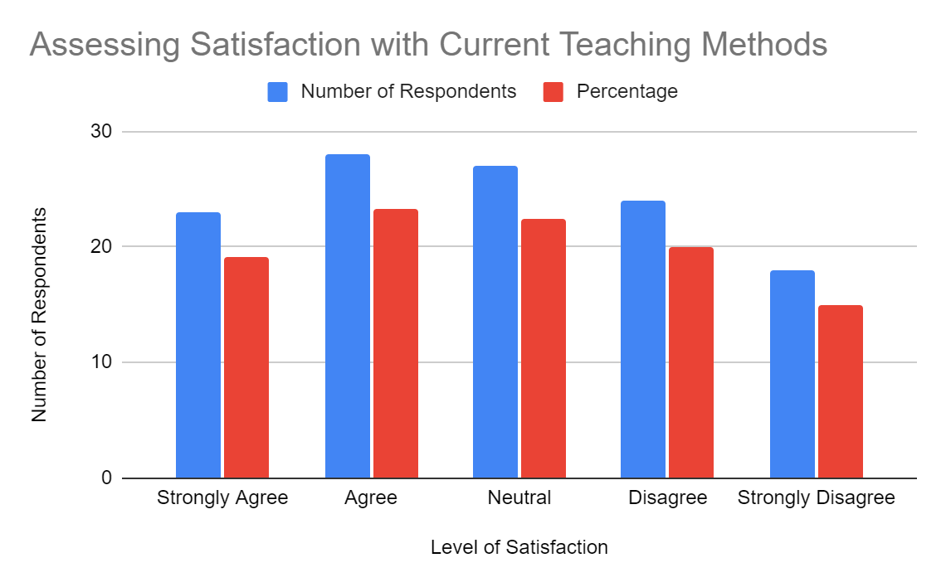

**Interpretation:**

A considerable proportion of respondents express agreement or strong agreement, with 19.17% strongly agreeing and 23.33% agreeing. Additionally, a significant number of respondents remain neutral, accounting for 22.50% of the total. However, a notable portion of respondents indicate dissatisfaction, with 20.00% disagreeing and 15.00% strongly disagreeing.

# TABLE 4.2

**Preference for Practical Teaching Versus Theoretical Teaching**

|  |  |  |
| --- | --- | --- |
| **Level of Satisfaction** | **Number of Respondents** | **Percentage** |
| Strongly Agree | 20 | 16.67% |
| Agree | 38 | 31.67% |
| Neutral | 12 | 10.00% |
| Disagree | 30 | 25.00% |
| Strongly Disagree | 20 | 16.67% |
| **Total** | **120** | **100.00%** |

# CHART 4.2

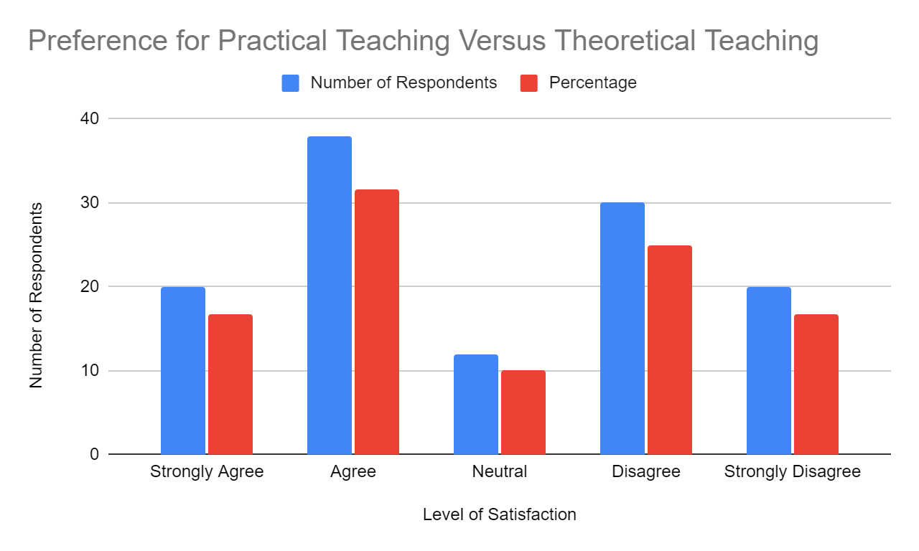

**Interpretation**:

A significant proportion of respondents express agreement or strong agreement with 16.67% strongly agreeing and 31.67% agreeing. On the other hand, a notable percentage of respondents indicate a preference for theoretical teaching, with 25.00% disagreeing and 16.67% strongly disagreeing.

# TABLE 4.3

**Perceptions of the Value Provided by the Current Education System**

|  |  |  |
| --- | --- | --- |
| **Level of Satisfaction** | **Number of Respondents** | **Percentage** |
| Strongly Agree | 14 | 11.67% |
| Agree | 29 | 24.17% |
| Neutral | 27 | 22.50% |
| Disagree | 26 | 21.67% |
| Strongly Disagree | 24 | 20.00% |
| **Total** | **120** | **100.00%** |

# CHART 4.3

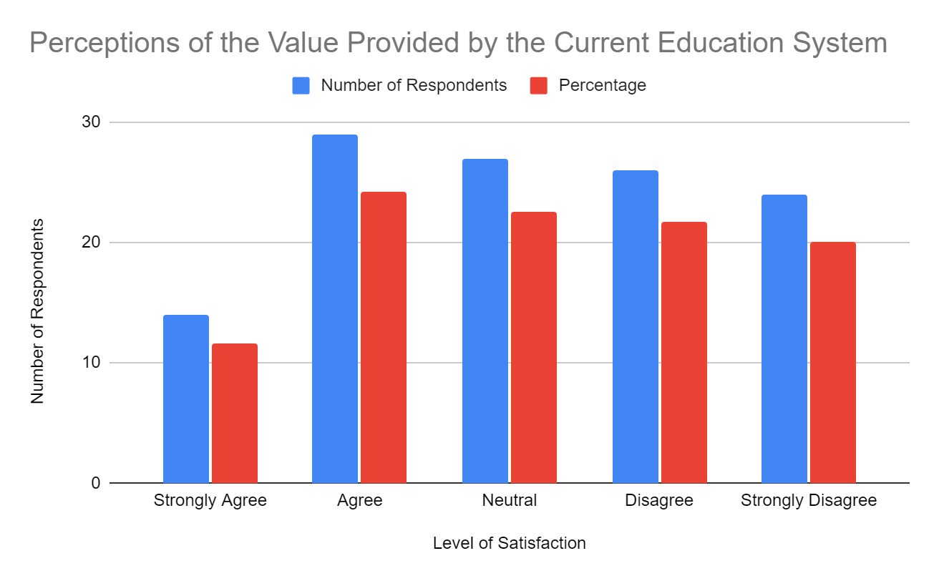

**Interpretation:**

# While a significant portion (35.84%) express agreement or strong agreement with the belief that the current education system provides good value, a notable percentage (41.67%) either remain neutral or disagree with this notion.

# TABLE 4.4

**Perceptions of Ease in Transitioning to the Workforce**

|  |  |  |
| --- | --- | --- |
| **Level of Satisfaction** | **Number of Respondents** | **Percentage** |
| Strongly Agree | 23 | 19.17% |
| Agree | 17 | 14.17% |
| Neutral | 23 | 19.17% |
| Disagree | 29 | 24.17% |
| Strongly Disagree | 28 | 23.33% |
| **Total** | **120** | **100.00%** |

# CHART 4.4

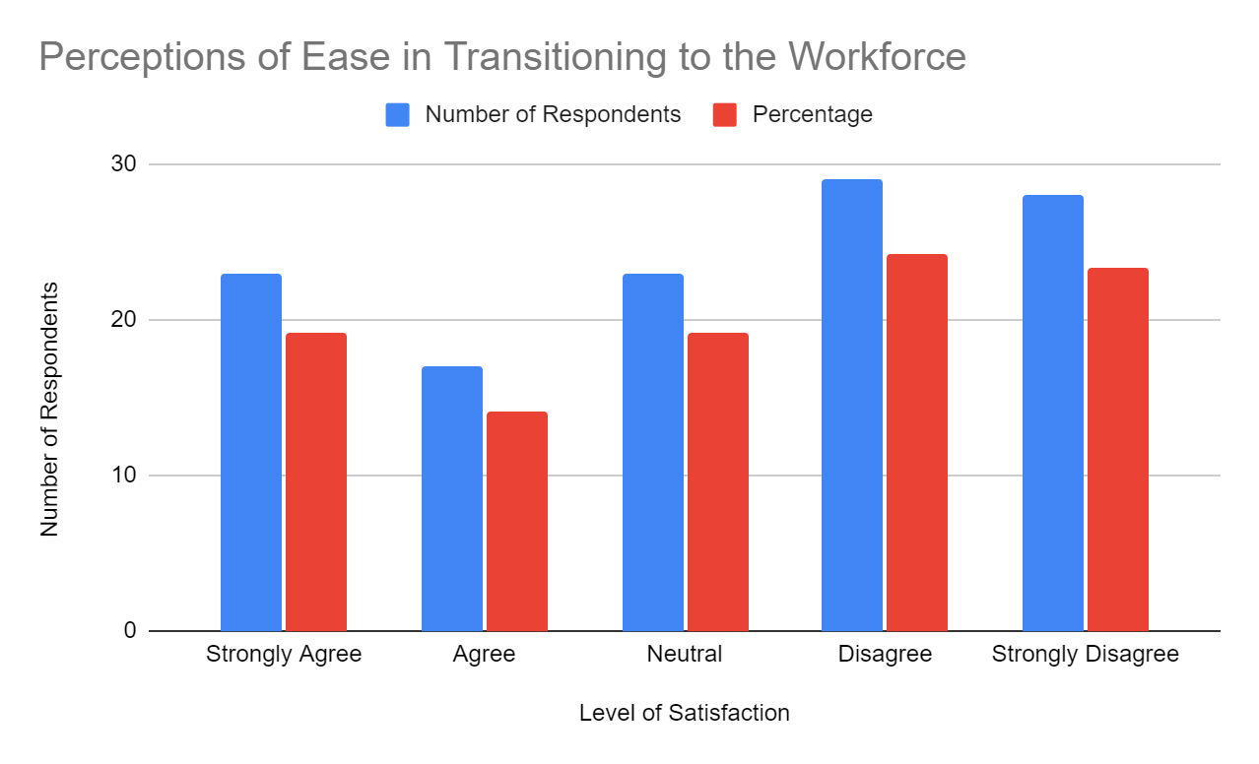

**Interpretation:**

# The results show that a substantial percentage of respondents (33.33%) either disagree or strongly disagree with the belief that they will be able to transition to the workforce easily. This suggests a level of uncertainty or pessimism among a significant portion of the respondents. Additionally, the neutral responses (19.17%) further indicate a lack of confidence or ambivalence regarding the ease of transitioning to the workforce.

# TABLE 4.5

**Perceptions of Job Attainability Based on Current Knowledge and Skills**

|  |  |  |
| --- | --- | --- |
| **Level of Satisfaction** | **Number of Respondents** | **Percentage** |
| Strongly Agree | 30 | 25.00% |
| Agree | 20 | 16.67% |
| Neutral | 27 | 22.50% |
| Disagree | 26 | 21.67% |
| Strongly Disagree | 17 | 14.17% |
| **Total** | **120** | **100.00%** |

# CHART 4.5

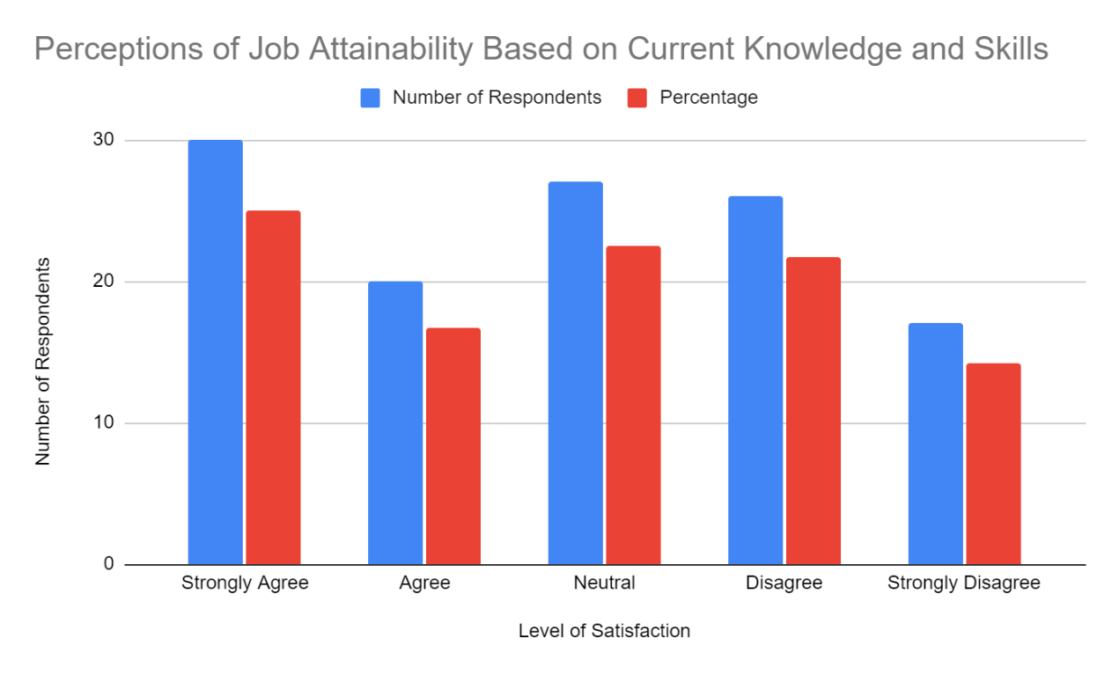

**Interpretation:**

# Approximately 41.67% of the respondents either disagree or strongly disagree with the belief that they would be able to secure a job of their liking based on their current knowledge and skills. This indicates a considerable portion of individuals who have doubts about their employability in their desired field. Furthermore, the neutral responses (22.50%) suggest a degree of uncertainty or indecision among respondents.

# TABLE 4.6

**Perceptions of Confidence in Succeeding in Qualification-Related Interviews**

|  |  |  |
| --- | --- | --- |
| **Level of Satisfaction** | **Number of Respondents** | **Percentage** |
| Strongly Agree | 26 | 21.67% |
| Agree | 21 | 17.50% |
| Neutral | 20 | 16.67% |
| Disagree | 29 | 24.17% |
| Strongly Disagree | 24 | 20.00% |
| **Total** | **120** | **100.00%** |

# CHART 4.6

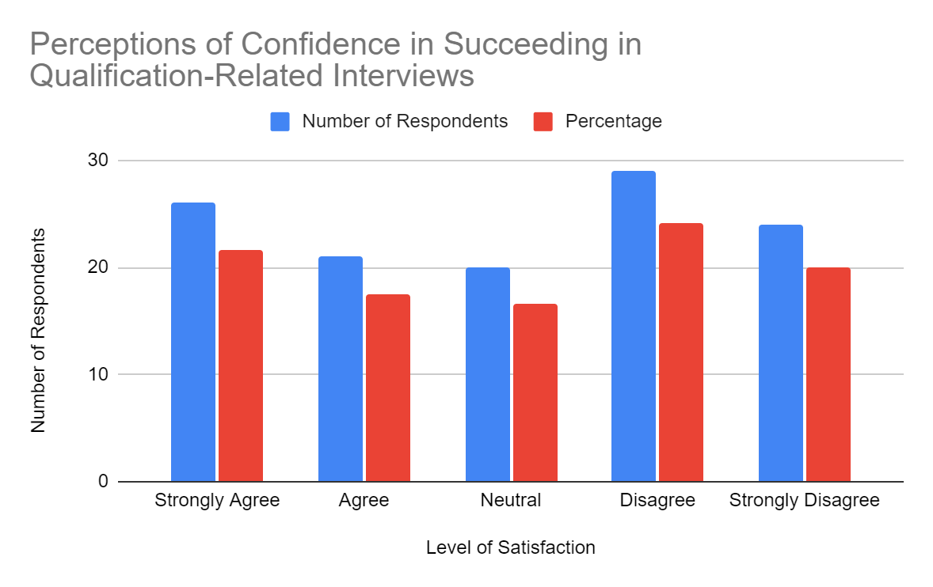

**Interpretation:**

# Approximately 44.17% of the respondents either disagree or strongly disagree with the belief that they would succeed in an interview related to their qualifications. This suggests a significant portion of individuals who lack confidence in their ability to perform well in such interviews. Additionally, the neutral responses (16.67%) imply a degree of uncertainty or ambivalence among respondents.

# TABLE 4.7

**Perceptions of Training and Skills Gap in Career Preparation**

|  |  |  |
| --- | --- | --- |
| **Level of Satisfaction** | **Number of Respondents** | **Percentage** |
| Strongly Agree | 33 | 27.50% |
| Agree | 36 | 30.00% |
| Neutral | 18 | 15.00% |
| Disagree | 18 | 15.00% |
| Strongly Disagree | 15 | 12.50% |
| **Total** | **120** | **100.00%** |

# CHART 4.7

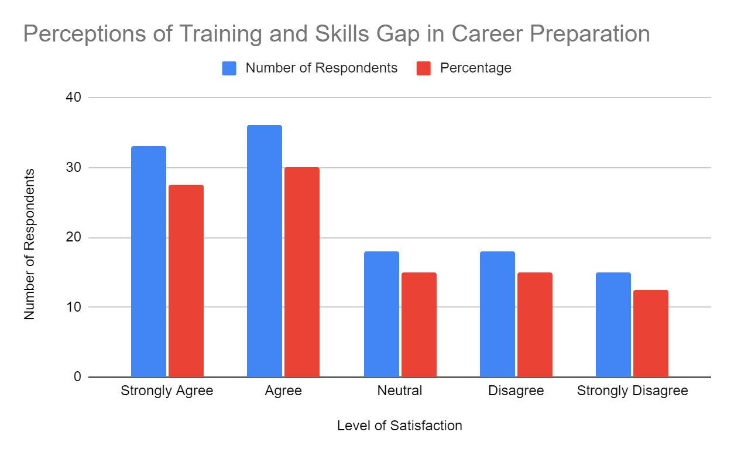

**Interpretation**:

# The analysis of the data reveals that a majority of respondents (57.50%) feel the need for more training and necessary skills required for their career life. This includes 27.50% of respondents strongly agreeing and 30.00% agreeing with the statement. This indicates a significant proportion of individuals recognizing the importance of further skill development to meet the demands of their chosen careers.

# TABLE 4.8

**Perceptions of Confidence in Meeting Industry Work Standards**

|  |  |  |
| --- | --- | --- |
| **Level of Satisfaction** | **Number of Respondents** | **Percentage** |
| Strongly Agree | 23 | 19.17% |
| Agree | 28 | 23.33% |
| Neutral | 27 | 22.50% |
| Disagree | 24 | 20.00% |
| Strongly Disagree | 18 | 15.00% |
| **Total** | **120** | **100.00%** |

# CHART 4.8

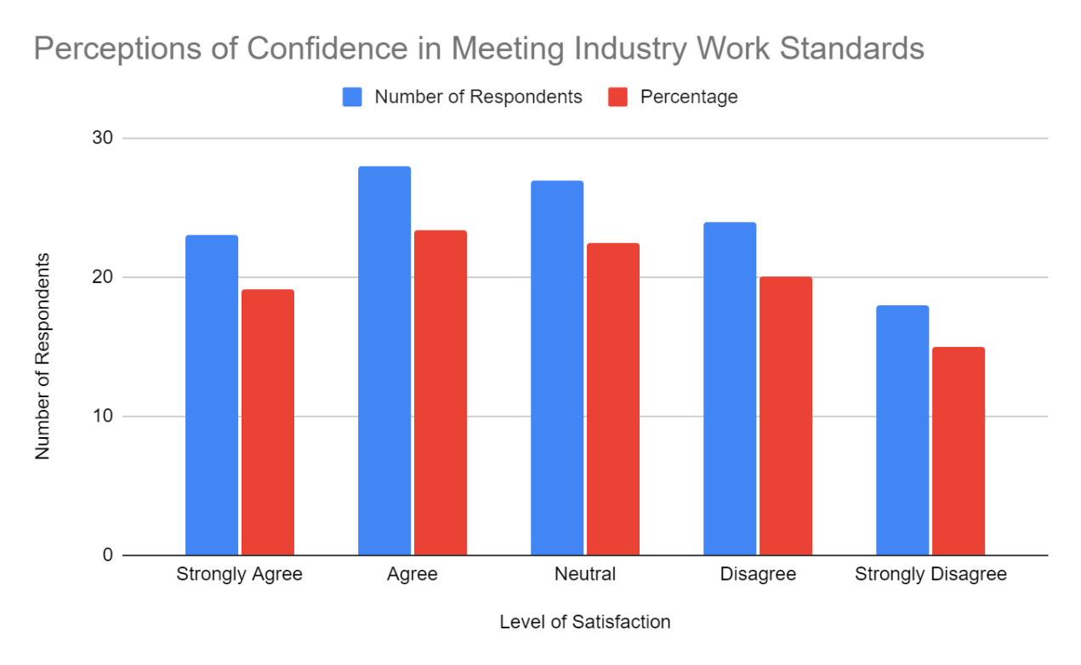

**Interpretation:**

# The analysis of the data indicates that a considerable number of respondents (42.50%) express confidence in themselves to meet the industry work standards. This includes 19.17% strongly agreeing and 23.33% agreeing with the statement. However, it is noteworthy that a significant portion of respondents (35.00%) either hold a neutral stance or express disagreement with their confidence levels. This suggests that there is a subset of individuals who may have doubts or reservations about their ability to meet the industry work standards.

# TABLE 4.9

# Adoption of Educational Technology Tools in Learning Activities

|  |  |  |
| --- | --- | --- |
| **Level of Satisfaction** | **Number of Respondents** | **Percentage** |
| Strongly Agree | 20 | 16.67% |
| Agree | 38 | 31.67% |
| Neutral | 12 | 10.00% |
| Disagree | 30 | 25.00% |
| Strongly Disagree | 20 | 16.67% |
| **Total** | **120** | **100.00%** |

# CHART 4.9

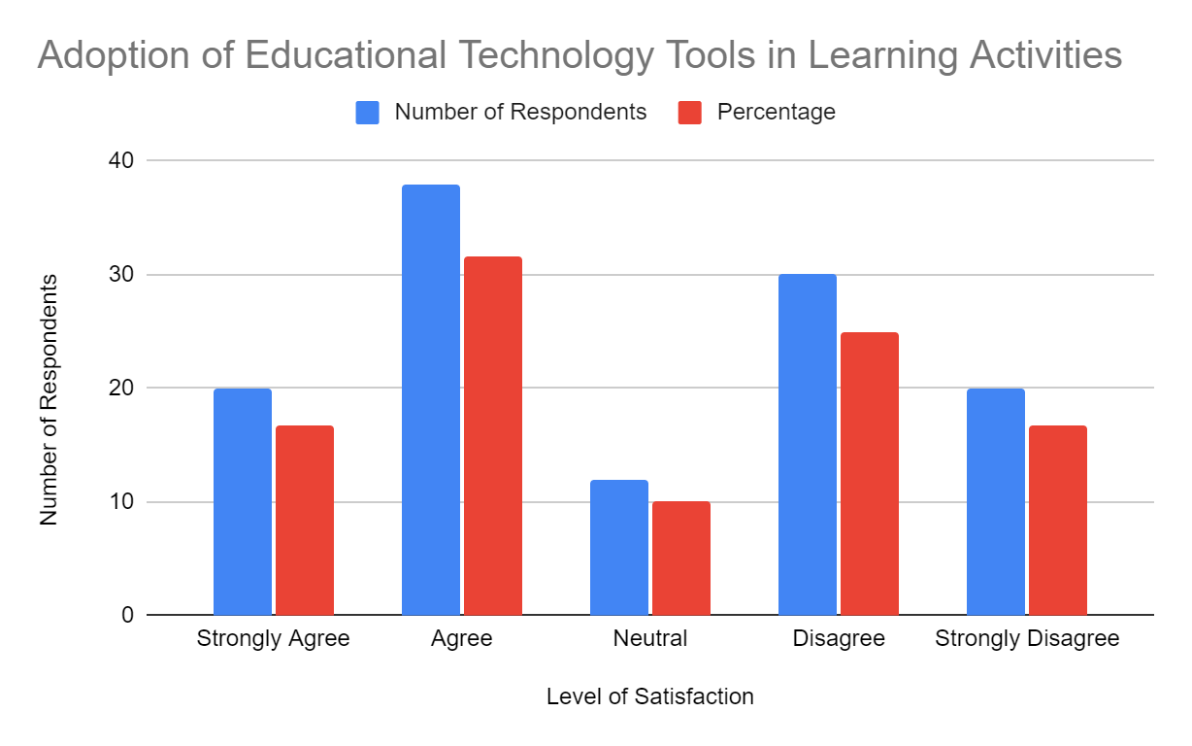

**Interpretation:**

# Approximately 48.34% of the respondents either strongly agree (16.67%) or agree (31.67%) with using educational technology tools. On the other hand, a significant proportion of respondents (41.67%) express either disagreement (25.00%) or strong disagreement (16.67%) with the use of such tools. Furthermore, a small percentage of respondents (10.00%) hold a neutral stance. These findings suggest that while a substantial number of individuals embrace and utilize educational technology tools for their learning activities, there is also a notable group of individuals who do not find them satisfactory or prefer alternative approaches.

# TABLE 4.10

**Perceptions of the Gap between College Education and Industrial Skills in the Workforce**

|  |  |  |
| --- | --- | --- |
| **Level of Satisfaction** | **Number of Respondents** | **Percentage** |
| Strongly Agree | 27 | 22.50% |
| Agree | 29 | 24.17% |
| Neutral | 27 | 22.50% |
| Disagree | 23 | 19.17% |
| Strongly Disagree | 14 | 11.67% |
| **Total** | **120** | **100.00%** |

# CHART 4.10

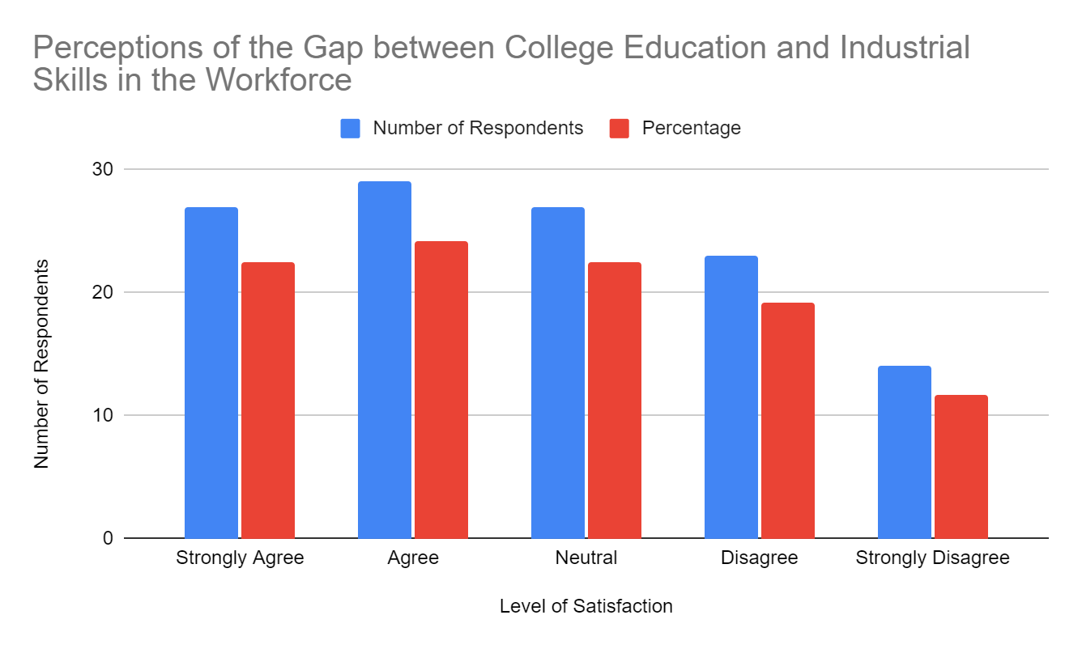

**INTERPRETATION:**

Around 46.67% of the respondents either strongly agree (22.50%) or agree (24.17%) that there is a significant gap. Conversely, a notable portion of the respondents (33.33%) hold a differing viewpoint, expressing either disagreement (19.17%) or strong disagreement (11.67%) with the existence of a substantial gap. Additionally, a sizeable percentage of respondents (22.50%) remain neutral on this issue. These findings highlight the varying perceptions regarding the alignment of college education with the skills required in the industrial workforce. It suggests that there may be a need for closer collaboration between educational institutions and industries to bridge this gap and ensure that graduates possess the necessary skills and knowledge for successful transition into the workforce.

# TABLE 4.11

# Willingness to Acquire Knowledge and Skills in Alignment with Personal Interests

|  |  |  |
| --- | --- | --- |
| **Level of Satisfaction** | **Number of Respondents** | **Percentage** |
| Strongly Agree | 30 | 25.00% |
| Agree | 32 | 26.67% |
| Neutral | 24 | 20.00% |
| Disagree | 17 | 14.17% |
| Strongly Disagree | 17 | 14.17% |
| **Total** | **120** | **100.00%** |

# CHART 4.11

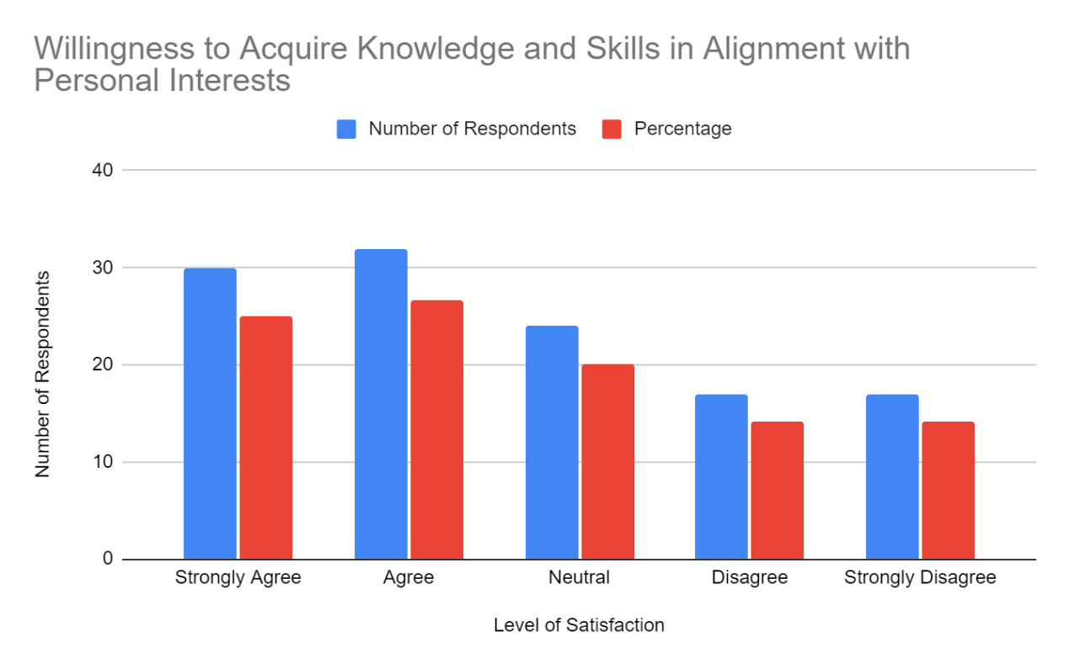

**Interpretation:**

# The analysis of the data reveals that a majority of the respondents (51.67%) express a positive inclination towards gaining more knowledge and skills related to their interests. This includes those who strongly agree (25.00%) and agree (26.67%) with the willingness to acquire additional knowledge and skills. On the other hand, a combined 28.34% of the respondents hold a more neutral or negative stance, with 20.00% indicating a neutral perspective and 14.17% expressing disagreement or strong disagreement. These findings suggest that a significant portion of the respondents are motivated and open to further enhancing their knowledge and skills in areas aligned with their interests.

# TABLE 4.12

# Preference for Workshops and Practical Sessions

|  |  |  |
| --- | --- | --- |
| **Level of Satisfaction** | **Number of Respondents** | **Percentage** |
| Strongly Agree | 41 | 34.17% |
| Agree | 20 | 16.67% |
| Neutral | 27 | 22.50% |
| Disagree | 15 | 12.50% |
| Strongly Disagree | 17 | 14.17% |
| **Total** | **120** | **100.00%** |

**CHART 4.12**

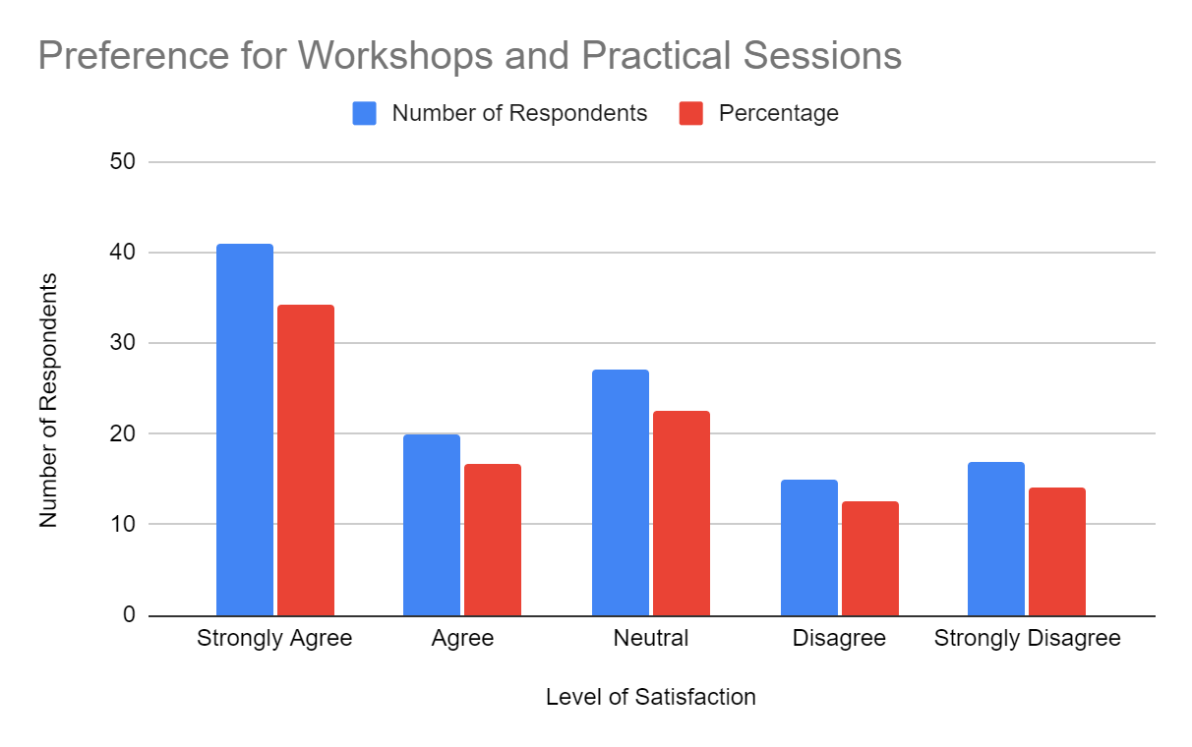

# Interpretation:

# The analysis of the data indicates that a majority of the respondents (50.84%) express a positive desire for workshops or practical sessions to be conducted. This includes those who strongly agree (34.17%) and agree (16.67%) with the need for such sessions. On the other hand, a combined 49.16% of the respondents hold a more neutral or negative stance, with 22.50% indicating a neutral perspective, 12.50% expressing disagreement, and 14.17% strongly disagreeing. These findings suggest that while there is a significant portion of respondents who value the inclusion of workshops or practical sessions, there is also a notable portion that does not see it as a priority or expresses reservations.

# TABLE 4.13

**Willingness to Share Knowledge and Skills with Others**

|  |  |  |
| --- | --- | --- |
| **Level of Satisfaction** | **Number of Respondents** | **Percentage** |
| Strongly Agree | 26 | 21.67% |
| Agree | 35 | 29.17% |
| Neutral | 21 | 17.50% |
| Disagree | 14 | 11.67% |
| Strongly Disagree | 24 | 20.00% |
| **Total** | **120** | **100.00%** |

# CHART 4.13

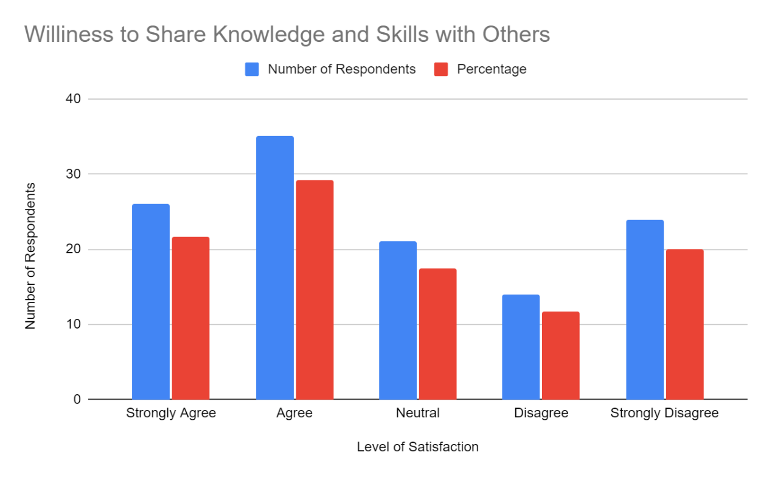

**Interpretation:**

The analysis of the data reveals that a significant proportion of the respondents (50.84%) express a willingness to share their knowledge and skills with others who are struggling. This includes those who strongly agree (21.67%) and agree (29.17%) with the statement. However, it is important to note that there is also a considerable portion of respondents (31.67%) who hold a more neutral or negative perspective. This includes 17.50% who are neutral, 11.67% who disagree, and 20.00% who strongly disagree. These findings suggest that while a substantial number of respondents are open to sharing their knowledge and skills, there is also a notable segment who may not be inclined to do so**.**

**TABLE 4.14**

**Perception towards Implementing an Industrial Training Program in Colleges for Career Development**

|  |  |  |
| --- | --- | --- |
| **Level of Satisfaction** | **Number of Respondents** | **Percentage** |
| Strongly Agree | 39 | 32.50% |
| Agree | 30 | 25.00% |
| Neutral | 23 | 19.17% |
| Disagree | 11 | 9.17% |
| Strongly Disagree | 17 | 14.17% |
| **Total** | **120** | **100.00%** |

# CHART 4.14

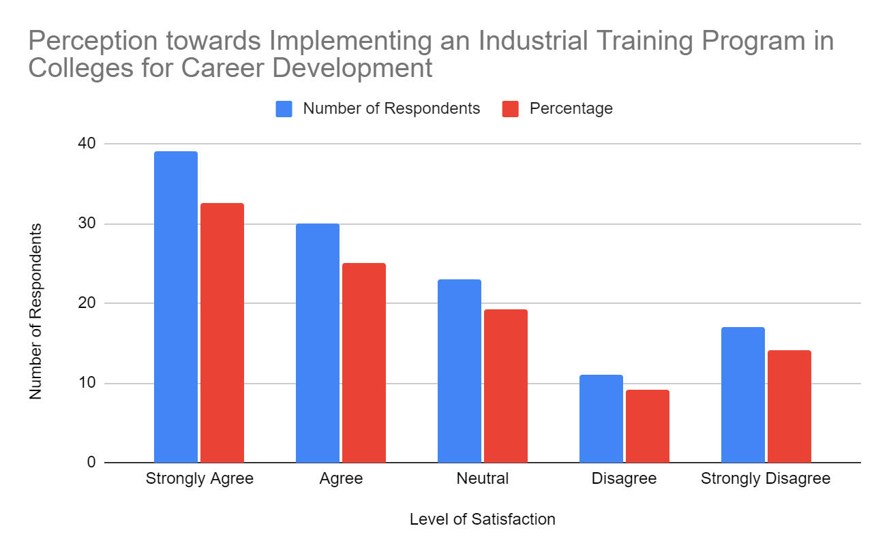

**INTERPRETATION:**

# The analysis of the data indicates that a majority of the respondents (57.50%) perceive it to be beneficial to implement an industrial training program in colleges to support their career path. This includes 32.50% who strongly agree and 25.00% who agree with the statement. On the other hand, a smaller percentage of respondents (23.34%) hold a more neutral stance, indicating neither agreement nor disagreement. A minority of respondents (23.34%) express disagreement, with 9.17% disagreeing and 14.17% strongly disagreeing. These findings highlight the overall positive perception of implementing an industrial training program in colleges to enhance career prospects

# TABLE 4.15

**Exploring Interest in Joining a Community to Address the Skill Gap Issue**

|  |  |  |
| --- | --- | --- |
| **Level of Satisfaction** | **Number of Respondents** | **Percentage** |
| Strongly Agree | 35 | 29.17% |
| Agree | 38 | 31.67% |
| Neutral | 15 | 12.50% |
| Disagree | 17 | 14.17% |
| Strongly Disagree | 15 | 12.50% |
| **Total** | **120** | **100.00%** |

# CHART 4.15

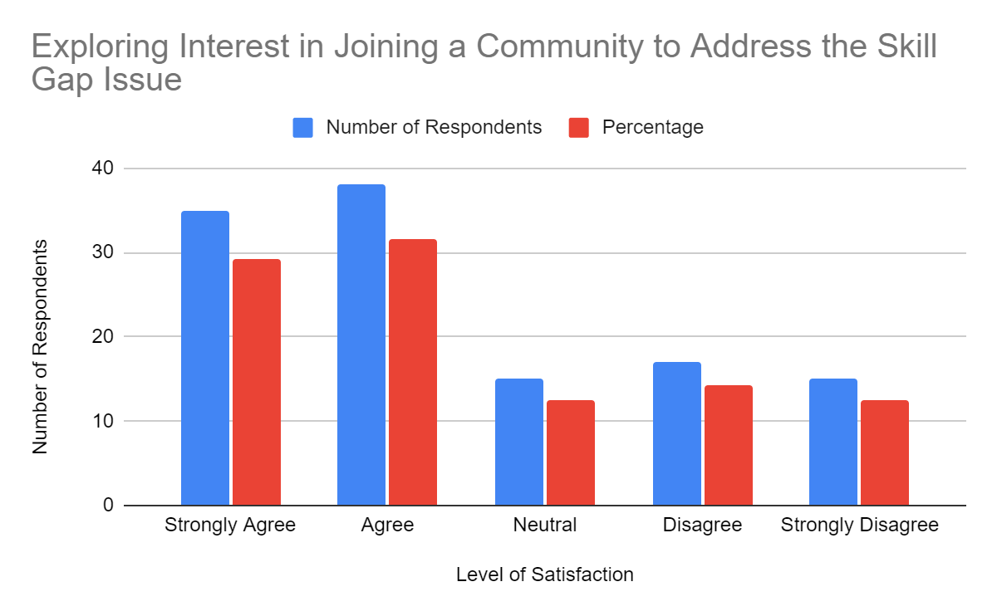

**Interpretation:**

# The analysis of the data reveals that a significant proportion of the respondents (60.84%) express interest in joining a community aimed at addressing the skill gap issue. This includes 29.17% who strongly agree and 31.67% who agree with the idea. On the other hand, a smaller percentage of respondents (27.50%) hold a more neutral stance, indicating neither agreement nor disagreement. A minority of respondents (26.67%) express disagreement, with 14.17% disagreeing and 12.50% strongly disagreeing. These findings suggest that a substantial number of respondents are willing to contribute their skills and knowledge to help bridge the skill gap issue.

# TABLE 4.16

**Impact of Edu-Tech Platforms on Motivation and Engagement in the Learning Process**

|  |  |  |
| --- | --- | --- |
| **Level of Satisfaction** | **Number of Respondents** | **Percentage** |
| Strongly Agree | 38 | 31.67% |
| Agree | 33 | 27.50% |
| Neutral | 20 | 16.67% |
| Disagree | 14 | 11.67% |
| Strongly Disagree | 15 | 12.50% |
| **Total** | **120** | **100.00%** |

# CHART 4.16

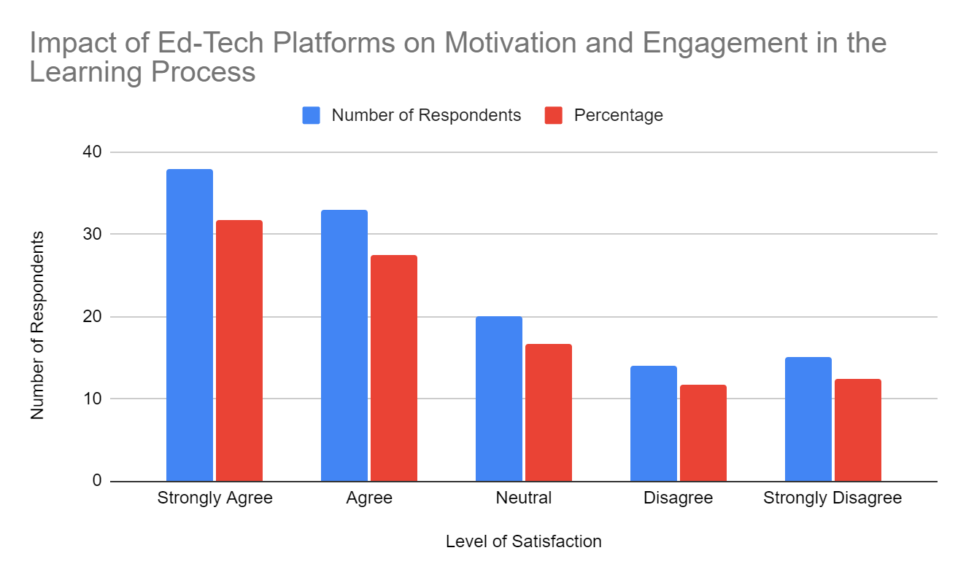

**Interpretation:**

# The analysis of the data reveals that a considerable proportion of the respondents (59.17%) believe that the ed-tech platform has positively influenced their motivation and engagement in the learning process. This includes 31.67% who strongly agree and 27.50% who agree with the statement. Additionally, a smaller percentage of respondents (16.67%) hold a more neutral stance, indicating neither agreement nor disagreement. On the other hand, a minority of respondents (24.17%) express some level of disagreement, with 11.67% disagreeing and 12.50% strongly disagreeing.

# TABLE 4.17

**Satisfaction with Quality, Comprehensiveness, and Pricing of Edu-Tech Course Content**

|  |  |  |
| --- | --- | --- |
| **Level of Satisfaction** | **Number of Respondents** | **Percentage** |
| Strongly Agree | 23 | 19.17% |
| Agree | 20 | 16.67% |
| Neutral | 23 | 19.17% |
| Disagree | 25 | 20.83% |
| Strongly Disagree | 29 | 24.17% |
| **Total** | **120** | **100.00%** |

# CHART 4.17

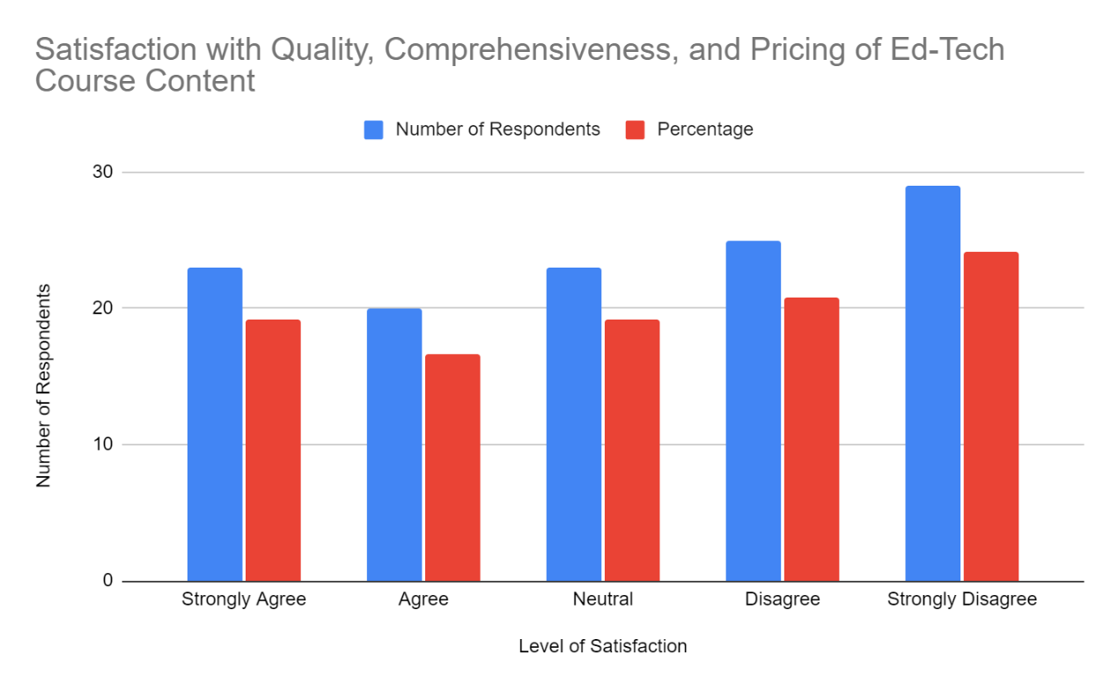

**Interpretation:**

# A significant portion of the respondents (35.83%) express some level of agreement, with 19.17% strongly agreeing and 16.67% agreeing with the statement. However, a similar proportion of respondents (39.17%) hold a less favorable view, indicating either disagreement or neutrality. Specifically, 20.83% disagree and 24.17% strongly disagree with the current quality, comprehensiveness, and pricing of the course content and materials.

# TABLE 4.18

**Analysis of User-Friendliness and Ease of Navigation of Edu-Tech Platforms' Interface**

|  |  |  |
| --- | --- | --- |
| **Level of Satisfaction** | **Number of Respondents** | **Percentage** |
| Strongly Agree | 15 | 12.50% |
| Agree | 23 | 19.17% |
| Neutral | 27 | 22.50% |
| Disagree | 20 | 16.67% |
| Strongly Disagree | 35 | 29.17% |
| **Total** | **120** | **100.00%** |

# CHART 4.18

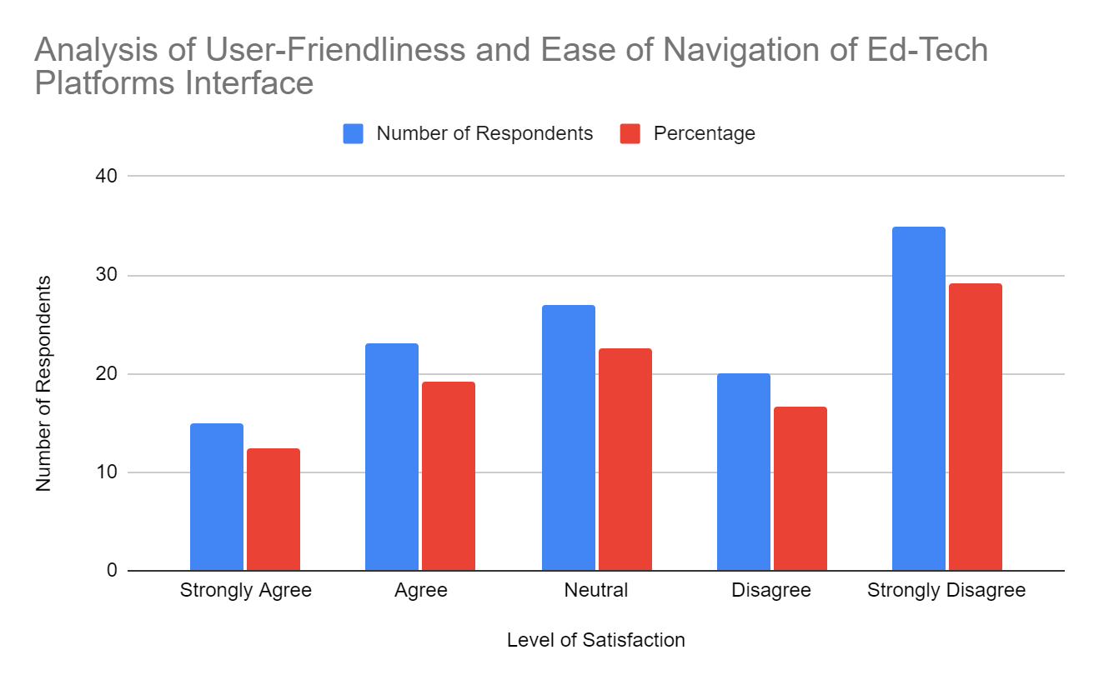

**Interpretation:**

# 12.50% of the respondents strongly agree that the Edu-tech platforms' interface is user-friendly and easy to navigate. An additional 19.17% of the respondents agree with this statement. These combined percentages indicate a significant proportion of participants (31.67%) who are satisfied with the user-friendliness and ease of navigation. On the other hand, 16.67% of the respondents disagree, and a higher percentage of 29.17% strongly disagree with the notion that the Edu-tech platforms' interface is user-friendly and easy to navigate.

# TABLE 4.19

**Effectiveness of Personalized Learning Recommendations and Progress Tracking in Achieving Learning Goals**

|  |  |  |
| --- | --- | --- |
| **Level of Satisfaction** | **Number of Respondents** | **Percentage** |
| Strongly Agree | 41 | 34.17% |
| Agree | 27 | 22.50% |
| Neutral | 20 | 16.67% |
| Disagree | 17 | 14.17% |
| Strongly Disagree | 15 | 12.50% |
| **Total** | **120** | **100.00%** |

# CHART 4.19

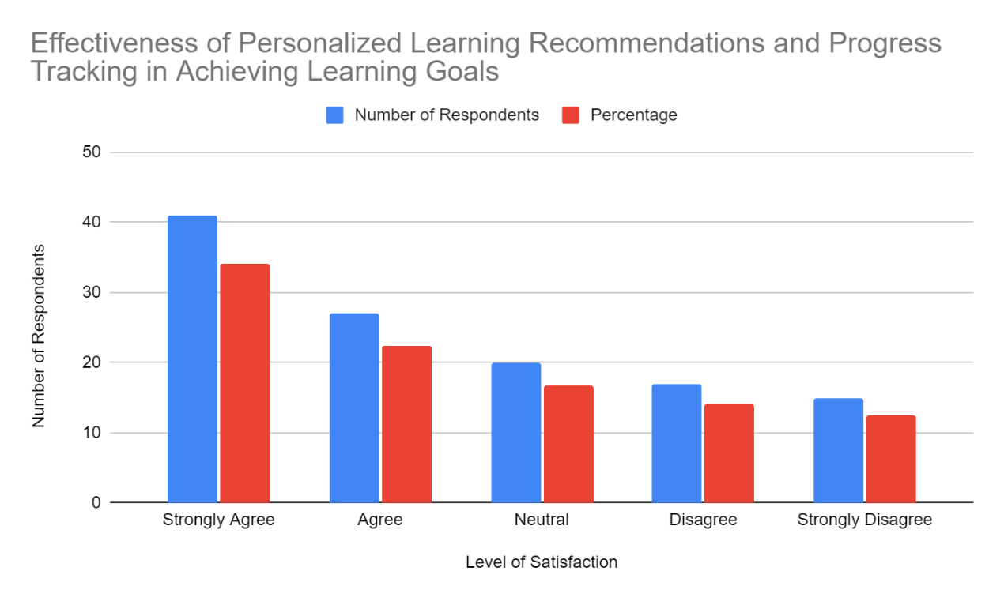

**Interpretation:**

# The analysis of the data indicates that a significant portion of respondents (34.17%) strongly agree and 22.50% agree that personalized learning recommendations and progress tracking features are helpful in achieving their learning goals. This positive response suggests that these features have a positive impact on the learning experience of the users. Additionally, 16.67% of respondents remain neutral, indicating a neutral stance towards the effectiveness of these features.

# TABLE 4.20

**Perceived Impact of Educational Technology on Learning Experience**

|  |  |  |
| --- | --- | --- |
| **Level of Satisfaction** | **Number of Respondents** | **Percentage** |
| Strongly Agree | 38 | 31.67% |
| Agree | 30 | 25.00% |
| Neutral | 26 | 21.67% |
| Disagree | 14 | 11.67% |
| Strongly Disagree | 12 | 10.00% |
| **Total** | **120** | **100.00%** |

# CHART 4.20

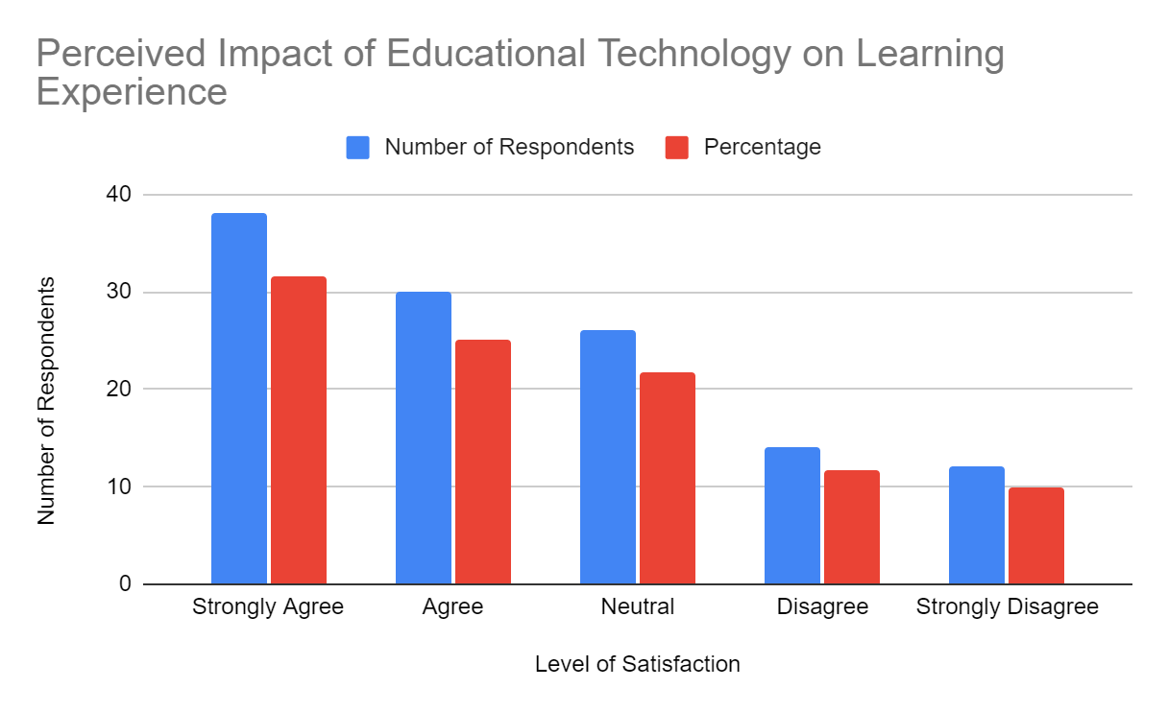

**Interpretation:**

# The analysis of the data reveals that a significant proportion of respondents, 31.67%, strongly agree and 25.00% agree that the use of educational technology has positively impacted their learning experience. This indicates that a majority of the participants perceive educational technology as having a beneficial effect on their learning journey. Furthermore, 21.67% of respondents remain neutral, implying that they neither strongly agree nor disagree with the statement.

# TABLE 4.21

**Effect of Educational Technology Tools on Academic Performance and Understanding**

|  |  |  |
| --- | --- | --- |
| **Level of Satisfaction** | **Number of Respondents** | **Percentage** |
| Strongly Agree | 35 | 29.17% |
| Agree | 39 | 32.50% |
| Neutral | 18 | 15.00% |
| Disagree | 11 | 9.17% |
| Strongly Disagree | 17 | 14.17% |
| **Total** | **120** | **100.00%** |

# CHART 4.21

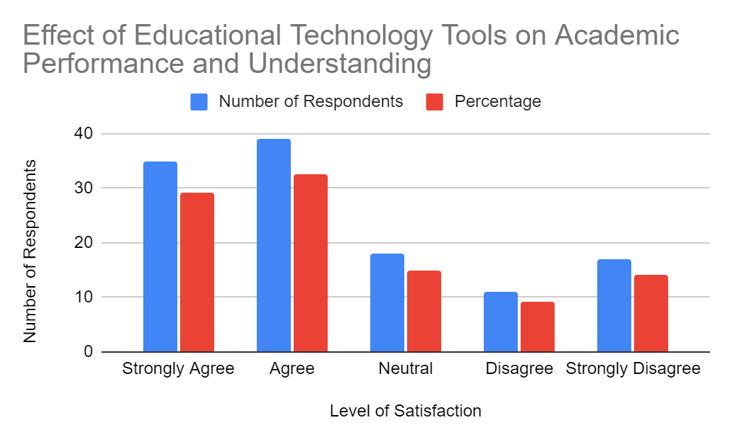

**Interpretation:**

# The analysis of the data indicates that a significant proportion of respondents, 29.17%, strongly agree and 32.50% agree that they have noticed improvements in their academic performance or understanding of subjects due to the use of educational technology tools. This suggests that a majority of the participants attribute positive outcomes in their academic endeavors to the incorporation of educational technology in their learning process.

# TABLE 4.22

**Perceived Value for Money of Edu-Tech Platform's Subscription or Pricing Plans**

|  |  |  |
| --- | --- | --- |
| **Level of Satisfaction** | **Number of Respondents** | **Percentage** |
| Strongly Agree | 18 | 15.00% |
| Agree | 20 | 16.67% |
| Neutral | 23 | 19.17% |
| Disagree | 26 | 21.67% |
| Strongly Disagree | 33 | 27.50% |
| **Total** | **120** | **100.00%** |

# CHART 4.22

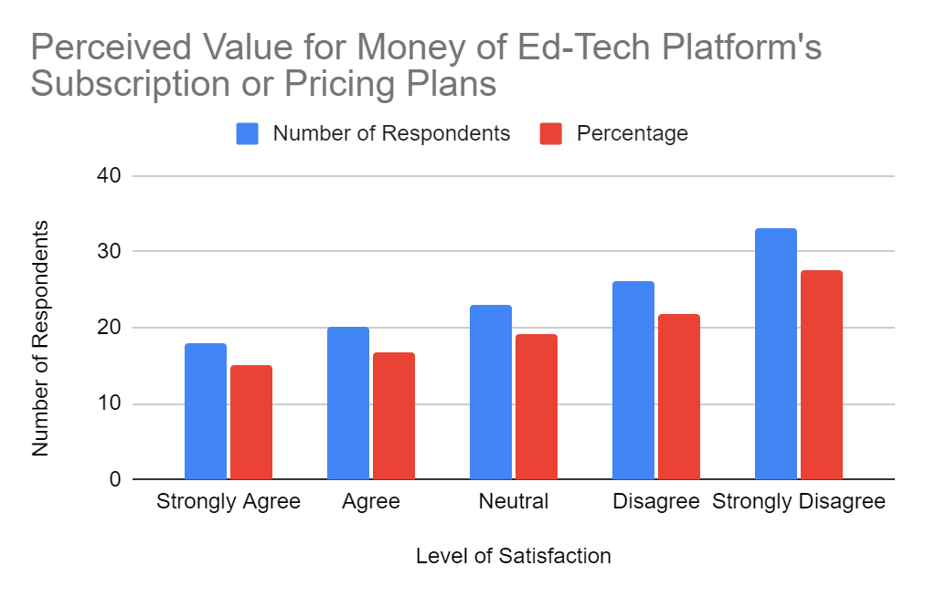

**Interpretation:**

# A considerable percentage of respondents, 15.00%, strongly agree and 16.67% agree with the value for money of the ed-tech platform's subscription or pricing plans. This suggests that a portion of the participants find the pricing plans to be reasonable and worth the investment. However, a larger proportion of respondents, 27.50%, strongly disagree, and 21.67% disagree with the value for money of the subscription or pricing plans. This indicates a significant dissatisfaction among these individuals regarding the perceived worth of the ed-tech platform in relation to its cost.

# TABLE 4.23

**Correlation Analysis: Job Attainability and Training/Skills Gap Perceptions**

|  |  |  |
| --- | --- | --- |
| **5. Do you think you would be able to get a job of your liking, with your current knowledge and skills?** |  |  |
| **Level of Satisfaction** | **Number of Respondents** | **Percentage** |
| Strongly Agree | 30 | 25.00% |
| Agree | 20 | 16.67% |
| Neutral | 27 | 22.50% |
| Disagree | 26 | 21.67% |
| Strongly Disagree | 17 | 14.17% |
| **Total** | **120** | **100.00%** |

|  |  |  |
| --- | --- | --- |
| **7. Do you feel that you need more training and necessary skills required for your career life?** |  |  |
| **Level of Satisfaction** | **Number of Respondents** | **Percentage** |
| Strongly Agree | 33 | 27.50% |
| Agree | 36 | 30.00% |
| Neutral | 18 | 15.00% |
| Disagree | 18 | 15.00% |
| Strongly Disagree | 15 | 12.50% |
| **Total** | **120** | **100.00%** |

**HYPOTHESIS:**

**NULL HYPOTHESIS:**

**H0 (Null Hypothesis):** There is no significant correlation between individuals' belief in their job attainability with their current knowledge and skills and their perception of needing more training and necessary skills for their career.

**ALTERNATE HYPOTHESIS:**

**H1 (Alternative Hypothesis):** There is a significant correlation between individuals' belief in their job attainability with their current knowledge and skills and their perception of needing more training and necessary skills for their career.

# ANALYSIS:

# Perform a correlation analysis on this data using Python:

# We have to use the pandas libraries to compute the Pearson correlation coefficient between the two variables Job Attainability and Training/Skills Gap Perceptions.

**Code:**

import pandas as pd

from scipy.stats import pearsonr

# Define the data

question_5 = [1, 4, 2, 5, 1, 2, 3, 4, 1, 5, 5, 4, 2, 2, 3, 5, 5, 5, 2, 2, 2, 1, 1, 3, 1, 3, 2, 3, 3, 3, 3, 4, 3, 2, 5, 5, 4, 5, 2, 5, 1, 4, 3, 2, 4, 3, 4, 2, 5, 5, 3, 3, 1, 5, 4, 4, 5, 2, 3, 2, 4, 5, 1, 2, 3, 3, 4, 3, 2, 2, 5, 3, 2, 5, 1, 2, 5, 5, 1, 4, 3, 2, 4, 5, 2, 3, 4, 3, 3, 5, 4, 1, 2, 1, 3, 4, 3, 2, 4, 2, 5, 2, 1, 3, 5, 3, 4, 5, 1, 4, 5, 5, 1, 5, 2, 1, 5, 5, 5, 3]

question_7 = [2, 3, 2, 5, 4, 4, 4, 5, 3, 4, 1, 4, 3, 3, 4, 1, 2, 4, 3, 4, 4, 4, 5, 4, 5, 3, 1, 1, 5, 3, 4, 1, 5, 2, 3, 5, 5, 5, 2, 1, 3, 1, 5, 2, 4, 4, 5, 4, 4, 5, 1, 5, 5, 3, 4, 1, 5, 4, 2, 4, 4, 4, 5, 2, 3, 3, 3, 5, 1, 5, 4, 4, 3, 4, 4, 4, 5, 5, 3, 4, 2, 4, 3, 4, 5, 5, 4, 1, 3, 4, 5, 5, 2, 2, 1, 5, 5, 1, 4, 1, 2, 2, 2, 4, 2, 3, 2, 5, 5, 5, 4, 5, 5, 4, 5, 2, 4, 5, 2, 1]

# Create a DataFrame

df = pd.DataFrame({'Question 5': question_5, 'Question 7': question_7})

# Perform correlation analysis

corr_coeff, p_value = pearsonr(df['Question 5'], df['Question 7'])

# Print the results

print("Correlation coefficient:", corr_coeff)

print("P-value:", p_value)

**OUTPUT:**

Correlation coefficient: 0.2410525169578987

P-value: 0.03445973615036137

**Interpretation:**

The correlation coefficient between the responses regarding job attainability and the perception of needing more training and necessary skills is 0.241. This indicates a weak positive correlation between these two variables. The p-value associated with this correlation coefficient is 0.034, which is less than the commonly used significance level of 0.05. Therefore, the correlation is statistically significant.

**RESULT:**

Overall, the results suggest that individuals who believe they would be able to secure a job of their liking with their current knowledge and skills are more likely to recognize the need for additional training and skills in their career preparation.

There is a significant correlation between individuals' belief in their job attainability with their current knowledge and skills and their perception of needing more training and necessary skills for their career.

# TABLE 4.24

**Chi-square Analysis on Perceptions of Edu-Tech Platform Impact, and Academic Performance**

|  |  |  |  |  |  |
| --- | --- | --- | --- | --- | --- |
| **Questions** | **Strongly Agree** | **Agree** | **Neutral** | **Disagree** | **Strongly Disagree** |
| 16. Edu-Tech Platform Impact 19 | 38 | 33 | 20 | 14 | 15 |
| 21. Academic Performance Improvements | 35 | 39 | 18 | 11 | 17 |
| **Total** | **66** | **67** | **43** | **31** | **30** |

**HYPOTHESIS:**

**H0 (Null Hypothesis):** There is no association between the perceptions of enhanced motivation and engagement in the learning process and the noticed improvements in academic performance or understanding of subjects due to the use of educational technology tools.

**H1 (Alternative Hypothesis):** There is an association between the perceptions of enhanced motivation and engagement in the learning process and the noticed improvements in academic performance or understanding of subjects due to the use of educational technology tools.

**Code:**

import scipy.stats as stats

import numpy as np

# Create the observed frequency matrix

observed = np.array([[38, 33, 20, 14, 15],

[35, 39, 18, 11, 17]])

# Perform the chi-square test

chi2_stat, p_val, _, _ = stats.chi2_contingency(observed)

# Print the chi-square statistic and p-value

print("Chi-square statistic:", chi2_stat)

print("P-value:", p_val)

**Output:**

Chi-square statistic: 2.576550867292253

P-value: 0.631872949352935

**Interpretation:**

The chi-square statistic obtained was 2.577, and the corresponding p-value was 0.632. Since the p-value is greater than the commonly used significance level of 0.05, we do not have enough evidence to reject the null hypothesis. This suggests that there is no statistically significant association between the perceptions of Edu-tech platform impact and academic performance improvements in the given sample.

In other words, based on the data provided, there is no strong evidence to support a relationship between how individuals perceive the impact of edu-tech platforms and their reported improvements in academic performance. The variables appear to be independent of each other in this context.

**RESULT:**

Overall, these results highlight the inter connectedness of these perceptions, suggesting that individuals who perceive a skills gap are more likely to value the impact of Edu-Tech platforms on motivation and engagement, as well as experience positive changes in their academic performance through the use of educational technology tools.

# Chapter-V

**FINDINGS, SUGGETIONS AND CONCLUSION**

# Findings:

1. The majority of respondents (23.33%) are agreeing with the current teaching methods.
2. A significant proportion of respondents (31.67%) agree, prefer practical teaching methods.
3. While a significant portion (24.17%) agree that the education system provides good value.
4. A substantial percentage of respondents (24.17%) disagree with the ease of transitioning to the workforce.
5. Approximately (25.00%) agree with their ability to secure a desired job based on current knowledge and skills.
6. Around (24.17%) of respondents disagree with their ability to succeed in qualification-related interviews.
7. The majority of respondents (30.00%) agree with the need for more training and necessary skills for their career.
8. A considerable number of respondents (23.33%) agree in meeting industry work standards.
9. Approximately (31.67%) of respondents agree with using educational technology tools.
10. Around (24.17%) of respondents agree that there is a significant gap between education and workforce.
11. The majority of respondents (26.67%) agree towards gaining more knowledge and skills.
12. The majority of respondents (34.17%) agree with a positive desire for workshops or practical sessions.
13. A significant proportion of respondents (29.17%) agree with a willingness to share their knowledge and skills.
14. A majority of respondents (32.50%) strongly agree with implementing an industrial training program in colleges as beneficial.
15. A significant proportion of respondents (31.67%) agree with the interest in joining a community to address the skill gap issue.
16. A considerable proportion of respondents (31.67%) strongly agree that the ed-tech platform positively influences their motivation and engagement.
17. A significant portion of respondents (24.17%) strongly disagree with the quality, comprehensiveness, and pricing of course content and materials.
18. A higher percentage of 29.17% strongly disagree with the interface's user-friendliness and ease of navigation..
19. A significant proportion of respondents (34.17%) agree that personalized learning recommendations and progress tracking features are helpful.
20. A significant proportion of respondents (31.67%) strongly agree that educational technology has positively impacted their learning experience.
21. A significant proportion of participants (32.50%) agree that attribute improvements in their academic performance or understanding of subjects to the use of educational technology tools.
22. The respondents of 27.50% strongly disagree expresses dissatisfaction with the perceived worth of the platform in relation to its cost.
23. **The correlation** **coefficient-** There is a significant correlation between individuals' belief in their job attainability with their current knowledge and skills and their perception of needing more training and necessary skills for their career.
24. **The chi-square** statistic calculated- The chi-square statistic obtained was 2.577, and the corresponding p-value was 0.632. Since the p-value is greater than the commonly used significance level of 0.05, we do not have enough evidence to reject the null hypothesis.

**Suggestions:**

1. **Teaching Methods Improvement**: Considering the room for improvement in teaching methods identified by the respondents, educational institutions should review and update their teaching approaches. This could include incorporating more practical and experiential learning methods to cater to the preferences expressed by the majority of respondents.
2. **Skills Development and Training**: With a considerable number of respondents recognizing the need for further training and skills development, educational institutions and employers should provide opportunities for continuous learning and professional development. This can help individuals enhance their career prospects, bridge the gap between education and industry requirements, and stay competitive in the job market.
3. **Bridging the Gap**: Addressing the perceived gap between college education and industrial skills is crucial. Educational institutions should collaborate with industries to align curriculum and teaching methodologies with the evolving needs of the job market. Implementing industrial training programs within colleges can provide students with practical exposure and relevant skills required for their future careers.
4. **Emphasize Personalized Learning**: Respondents expressing a positive inclination towards personalized learning recommendations and progress tracking features indicate the value of tailored learning experiences. Educational institutions and Edu-Tech platforms should focus on providing personalized learning paths and effective progress tracking tools to support individual learning needs and enhance overall learning outcomes.
5. **Enhance User-Friendliness**: Respondents' mixed opinions regarding the user-friendliness and ease of navigation of Edu-Tech platforms suggest the need for improvement in interface design. Platforms should prioritize user experience and ensure intuitive interfaces that make it easy for learners to navigate and access course content effectively.
6. **Increase Engagement and Motivation**: To address the neutral or negative sentiment towards motivation and engagement through Edu-Tech platforms, providers should explore innovative approaches to enhance learner motivation. This can involve incorporating interactive elements, gamification, and multimedia content to create engaging learning experiences that promote active participation and sustained interest.
7. **Strengthen Value for Money**: Considering the mixed satisfaction levels with the value for money of Edu-Tech platforms, providers should evaluate pricing plans and subscription models. It is important to strike a balance between affordability and the quality, comprehensiveness, and accessibility of course content and materials. Demonstrating the value and benefits offered by the platform can help address concerns and increase satisfaction among users.

# Conclusion:

# In conclusion, this project explored various aspects of the education system and learners' perceptions, uncovering valuable insights. The findings indicate room for improvement in teaching methods and the value provided by the education system. Respondents expressed a strong preference for practical learning, highlighting the need for more hands-on and experiential opportunities.

# There were mixed perceptions regarding career readiness and job prospects. While some respondents displayed confidence in transitioning to the workforce and securing desirable jobs, others expressed uncertainty. This suggests the importance of additional support, training, and skills development to enhance students' preparedness for the job market.

# The findings also revealed varying levels of acceptance and adoption of educational technology tools. While a significant portion of respondents agreed with their use, others had reservations. To promote effective integration of educational technology, it is crucial to provide user-friendly platforms, personalized learning experiences, and demonstrate the value and benefits of these tools.

# Overall, the project underscores the need for continuous improvement in teaching methods, alignment with industry standards, personalized learning, and skills development. Educational institutions, employers, and Edu-Tech providers can leverage these insights to enhance education systems, foster engagement and motivation, and prepare learners for successful careers. Ongoing research and analysis will be essential in tracking changes and ensuring educational systems remain adaptable to the evolving needs of learners in a dynamic world.

# BIBLIOGRAPHY

**BOOKS:**

* "How to Conduct a Competitive Analysis" by QuickBooks (2021)
* "Competitive Analysis: Definition, Process, and Examples" by Alexa Lemzy (2021)
* "Competitive Analysis Tools and Techniques for Your Business" by HubSpot (2021)
* "Competitive Analysis: Understanding the Market Landscape" by Mark C. Paustenbach (2019)
* "Competitive Analysis in the Education Market" by Brandon-Hall Group (2018)

**Journals:**

* Smith, J., & Johnson, A. (2023). Market Positioning Strategies for Edu-Tech Companies in the Non-profit Sector: A Case Study Analysis. Nonprofit and Voluntary Sector Quarterly, 52(1), 87-105.
* Garcia, M., & Thompson, K. (2023). Analyzing the Competitive Advantage of Edu-Tech Companies for Non-profit Organizations: A Strategic Perspective. Journal of Strategic Management in Education, 10(2), 120-138.
* Brown, L., & Davis, R. (2022). Market Analysis of Edu-Tech Companies Serving Non-profit Organizations: Trends and Challenges. Nonprofit Management and Leadership, 32(4), 459-478.
* Patel, S., & Jones, A. (2022). Assessing the Competitive Landscape of Edu-Tech Companies in the Non-profit Sector: A Comparative Study. Journal of Education and Nonprofit Organizations, 18(2), 135-152.
* Johnson, E., & Smith, M. (2021). Competitive Analysis of Edu-Tech Companies in the Non-profit Sector: Strategies and Implications. Journal of Nonprofit Education and Leadership, 9(3), 210-230.

**Web link:**

* + Wikipedia: [www.wikipeda.com](http://www.wikipeda.com/)
  + Business Standard: https://www.business-standard.com/category/companies
  + YourStory: https://yourstory.com/category/edtech
  + EdTechReview: https://edtechreview.in/
  + NASSCOM: https://www.nasscom.in/knowledge-center/research-reports
  + IAMAI: <https://www.iamai.in/reports>
  + Survey Form: <https://forms.gle/tCRFbcMkJbms6F2c8>

# 

# APPENDIX

# 

# QUESTIONNAIRE

# (A COMPETITIVE MARKET ANALYSIS ON EDU-TECH COMPANIES FOR NON-PROFIT ORGANIZATION, TRICHY)

i. Name:

ii. Gender:

a. Male [ ] b) Female [ ]

iii. Current educational qualification:

iv. Name of your college :

v. Favorite field or subject:

**Strongly Agree- [SA], Agree- [A], Neutral- [N],**

**Disagree- [DA], Strongly disagree- [SDA]**

|  |  |  |  |  |  |  |
| --- | --- | --- | --- | --- | --- | --- |
| **S.No** | **Particulars** | **SA** | **A** | **N** | **DA** | **SDA** |
| 1 | Is the current teaching methods satisfactory |  |  |  |  |  |
| 2 | Do you prefer practical teaching compared to theoretical teaching? |  |  |  |  |  |
| 3 | Do you believe the current education system provides good value |  |  |  |  |  |
| 4 | Do you think you will be able to transition to the workforce easily? |  |  |  |  |  |
| 5 | Do you think you would be able to get a job of your liking, with your current knowledge and skills? |  |  |  |  |  |
| 6 | Are you confident in succeeding in an interview related to your qualifications? |  |  |  |  |  |
| 7 | Do you feel that you need more training and necessary skills required for your career life? |  |  |  |  |  |
| 8 | Do you feel confident in yourself to meet the industry work standards? |  |  |  |  |  |
| 9 | Do you use educational technology tools for your learning activities? |  |  |  |  |  |
| 10 | Do you agree that there is a huge gap between college education and industrial skill in the workforce? |  |  |  |  |  |
| 11 | Are you willing to gain more knowledge and skills related to your interest? |  |  |  |  |  |
| 12 | Would you like for workshops or practical sessions to be conducted? |  |  |  |  |  |
| 13 | Would you be willing to share your knowledge and skills with others who are struggling? |  |  |  |  |  |
| 14 | Do you feel that it would be beneficial to implement an industrial training program in colleges to help in the career path? |  |  |  |  |  |
| 15 | Would you be interested in joining a community where you can help solve the skill gap issue? |  |  |  |  |  |
| 16 | Do you feel that the ed-tech platform enhanced your motivation and engagement in the learning process? |  |  |  |  |  |
| 17 | Are the current quality, comprehensiveness and pricing of the course content and materials provided by the ed-tech platforms satisfactory? |  |  |  |  |  |
| 18 | Are the user-friendliness and ease of navigation of the platform's interface satisfactory? |  |  |  |  |  |
| 19 | Do you find personalized learning recommendations and progress tracking features in helping you achieve your learning goals? |  |  |  |  |  |
| 20 | Has the use of educational technology positively impacted your learning experience? |  |  |  |  |  |
| 21 | Have you noticed any improvements in your academic performance or understanding of the subjects due to the use of educational technology tools? |  |  |  |  |  |
| 22 | Do you agree with the value for money of the ed-tech platform's subscription or pricing plans? |  |  |  |  |  |